

[(Here is the link to the original PDF for this Paper)](https://drive.google.com/open?id=1ZcBB2mjuvnLY8bbH4jRux62aBK7D3epO&usp=drive_fs)

See discussions, stats, and author profiles for this publication at: [https://www.researchgate.net/publication/256981297](https://www.researchgate.net/publication/256981297_Effects_of_sound_and_ultrasound_on_Zebra_Mussels?enrichId=rgreq-4766b5667db1c3b45a01dc7f42751408-XXX&enrichSource=Y292ZXJQYWdlOzI1Njk4MTI5NztBUzo4NDk1OTg2MjUwOTk3NzdAMTU3OTU3MTUwNTMwMg%3D%3D&el=1_x_2&_esc=publicationCoverPdf)

[Effects of sound and ultrasound on Zebra Mussels.](https://www.researchgate.net/publication/256981297_Effects_of_sound_and_ultrasound_on_Zebra_Mussels?enrichId=rgreq-4766b5667db1c3b45a01dc7f42751408-XXX&enrichSource=Y292ZXJQYWdlOzI1Njk4MTI5NztBUzo4NDk1OTg2MjUwOTk3NzdAMTU3OTU3MTUwNTMwMg%3D%3D&el=1_x_3&_esc=publicationCoverPdf)

**Article** *in* The Journal of the Acoustical Society of America · April 1996

DOI: 10.1121/1.415087

 

CITATIONS

11

READS

1,080

**2 authors:**

[David A. Wright](https://www.researchgate.net/profile/David-Wright-63?enrichId=rgreq-4766b5667db1c3b45a01dc7f42751408-XXX&enrichSource=Y292ZXJQYWdlOzI1Njk4MTI5NztBUzo4NDk1OTg2MjUwOTk3NzdAMTU3OTU3MTUwNTMwMg%3D%3D&el=1_x_5&_esc=publicationCoverPdf)

[University of Maryland Center for Environmental Science](https://www.researchgate.net/institution/University-of-Maryland-Center-for-Environmental-Science?enrichId=rgreq-4766b5667db1c3b45a01dc7f42751408-XXX&enrichSource=Y292ZXJQYWdlOzI1Njk4MTI5NztBUzo4NDk1OTg2MjUwOTk3NzdAMTU3OTU3MTUwNTMwMg%3D%3D&el=1_x_6&_esc=publicationCoverPdf)

**122** PUBLICATIONS **3,929** CITATIONS

[Dimitri Donskoy](https://www.researchgate.net/profile/Dimitri-Donskoy?enrichId=rgreq-4766b5667db1c3b45a01dc7f42751408-XXX&enrichSource=Y292ZXJQYWdlOzI1Njk4MTI5NztBUzo4NDk1OTg2MjUwOTk3NzdAMTU3OTU3MTUwNTMwMg%3D%3D&el=1_x_5&_esc=publicationCoverPdf)

[Stevens Institute of Technology](https://www.researchgate.net/institution/Stevens_Institute_of_Technology?enrichId=rgreq-4766b5667db1c3b45a01dc7f42751408-XXX&enrichSource=Y292ZXJQYWdlOzI1Njk4MTI5NztBUzo4NDk1OTg2MjUwOTk3NzdAMTU3OTU3MTUwNTMwMg%3D%3D&el=1_x_6&_esc=publicationCoverPdf)

**100** PUBLICATIONS **1,344** CITATIONS

 

**Some of the authors of this publication are also working on these related projects:**

Ballast Water Research [View project](https://www.researchgate.net/project/Ballast-Water-Research?enrichId=rgreq-4766b5667db1c3b45a01dc7f42751408-XXX&enrichSource=Y292ZXJQYWdlOzI1Njk4MTI5NztBUzo4NDk1OTg2MjUwOTk3NzdAMTU3OTU3MTUwNTMwMg%3D%3D&el=1_x_9&_esc=publicationCoverPdf)

Sources of chlordane in Anacostia River fish [View project](https://www.researchgate.net/project/Sources-of-chlordane-in-Anacostia-River-fish?enrichId=rgreq-4766b5667db1c3b45a01dc7f42751408-XXX&enrichSource=Y292ZXJQYWdlOzI1Njk4MTI5NztBUzo4NDk1OTg2MjUwOTk3NzdAMTU3OTU3MTUwNTMwMg%3D%3D&el=1_x_9&_esc=publicationCoverPdf)

All content following this page was uploaded by [Dimitri Donskoy](https://www.researchgate.net/profile/Dimitri-Donskoy?enrichId=rgreq-4766b5667db1c3b45a01dc7f42751408-XXX&enrichSource=Y292ZXJQYWdlOzI1Njk4MTI5NztBUzo4NDk1OTg2MjUwOTk3NzdAMTU3OTU3MTUwNTMwMg%3D%3D&el=1_x_10&_esc=publicationCoverPdf) on 21 January 2020.

The user has requested enhancement of the downloaded file.

*TR-2736*

**Davidson· Laboratory**

Marine Hydrodynamics, Coastal & Ocean Epgineering

TECHNICAL REPORT SIT-DL-96-9-2736 FEBRUARY 1996

THE USE OF ACOUSTIC, VIBRATIONAL, AND HYDRODYNAMIC TECHNIQUES TO CONTROL ZEBRA MUSSEL INFESTATION

by

Dr. Dimitri M. Donskoy Prepared for

New Jersey Marine Sciences Consortium under

Sea Grant Project No. R/E-29AM, (NOAA Award No. NA26RG0403-0l

(Davidson Laboratory Project 5437/629)

**STEVENS**

# Institute of Technology

**Castle Point on Hudson**

**. Hoboken, NJ 07030**

##### TECHNICAL REPORT SIT-DL-96-9-2736 FEBRUARY 1996

THE USE OF ACOUSTIC, VIBRATIONAL, AND HYDRODYNAMIC TECHNIQUES TO CONTROL ZEBRA MUSSEL INFESTATION

by

##### Dr. Dimitri M. Donskoy Prepared for

New Jersey Marine Sciences Consortium under

##### Sea Grant Project No. R/E-29ZM, (NOAA Award No. NA26RG0403-0l

under

Davidson Laboratory Project 5437/629

APPROVED

Michael S. Bruno

Director

| **TABLE OF CONTENTS** |  |
| --- | --- |
| 1. INTRODUCTION................................................................................................... | 1 |
| 1.1. Background..................................................................................................... | 1 |
| 1.2. Review of literature......................................................................................... | 1 |
| 1.2.1 The biology of the zebra mussel................................................................ | 1 |
| 1.2.2. Control of the zebra mussel..................................................................... | 3 |
| 1.2.3. Acoustic energy as a control measure....................................................... | 4 |
| 1.2.4. Summary of the reviewed studies on acoustic control of zebra mussels...... | 7 |
| 1.3. Objectives........................................................................................................ | 9 |
| 2. MUSSEL COLLECTION, COUNTING, AND DATA ANALYSIS ....................... | 9 |
| 2.1. Site and facilities ............................................................................................. | 9 |
| 2.2. Sample collection ............................................................................................ | 14 |
| 2.3. Counting procedure ......................................................................................... | 15 |
| 3. HYDRODYNAMIC AND ULTRASOUND CAVITATION JESTS ...................... | l? |
| 3.1. Equipment ....................................................................................................... | 17 |
| 3.2. Results of the tests ........................................................................................... | 19 |

* 1. Summary 25

1. VIBRATION EFFECT ON ZEBRA MUSSEL VELIGERS 26
   1. Equipment and methodology 26
   2. Results of the tests 26
2. SOUND 30
   1. Sound and cavitation detachment tests 32
   2. Adult mussel :.filtering activity test 32
   3. Sound control of juvenile and adult mussel translocation 36
   4. Effect of sound on veliger's settlement abilities 49
   5. Effect of Low Frequency Sound on Spawning and Reproduction in Dreissenid Mussels 51
   6. hnpact of sound on non-target organisms 53
   7. Discussion 55
3. ULTRASOUND EVALUATION OF ZEBRA MUSSEL POPULATION 55
4. CONCLUSION 59

LITERATURE 62

ACKN'OWLEDGMENTS 67

## INTRODUCTION

### Background

The freshwater bivalve mollusk, *Dreissena polymorpha* (Pallas, 1771) - better known as the zebra mussel - is a native of southern Russia, and since its introduction into the Great Lakes, apparently in 1985 or 1986, this mollusk has been quickly spreading throughout the waterways of both the United States and Canada. The broad physiological adaptive capabilities and genetic plasticity of this species, coupled with dispersal via human modes, predispose it to an eventual wide distribution in North America - with potentially serious economic and environmental consequences.

The economics of the problem are only now beginning to be understood as the extent of the zebra mussel's invasion becomes clear and its impact on utilities and other water users is begun to be felt. In 1989 and 1990, densities of zebra mussels in lake Erie approached 1,000,000 per square meter at large water intakes. Cities, such as Monroe, Michigan, were losing their water supply, and utilities were experiencing flow reduction of more than 30 percent (Reutter, 1995). The U.S. Fish and Wildlife Service has estimated that the cost of industrial, utility, and municipal water use reductions due to biofouling, plus the impact of the zebra mussel on navigation, boating, and sport fishing, could reach $5 billion by the year 2000 in the Great Lakes alone.1 Since their introduction, zebra mussels have spread to 18 states, increasing the overall cost of this invasion.

### Review of Literature

* + 1. **The Biology of the Zebra Mussel**

**Life history.** The life span for the zebra mussel is typically three to five years, but there are data in the Russian literature that it can live six to nine years (Mikheev 1964) and even up to 15 years



United States Fisheries and Wildlife Service, unpublished data.

(Karpevich 1964). Such a difference can probably be explained by differences in water temperature in habitats, because it is known that the life span of mussels both in fresh water and seawater depends mainly on water temperature. The shells of adult mussels average 25-35mm in length, with some mussels having shells as long as 50mm (Kirpichenko 1971).

Typically, zebra mussels mature sexually in their second year (in Europe), although in Lake Erie and Lake St. Clair they generally have been maturing in their first year of life. Sexual maturity has been achieved in mussels as small as three millimeters in length, according to recent North American studies (Nichols et al. 1993). These scientists also emphasized that the reproductive cycle of the mussel is readily affected by local environmental conditions.

As for reproduction, the sexes are separate, and gametes are released either synchronously or asynchronously into the water column for external fertilization. For fertilization the temperature must be higher than 12°C (Sprung 1993). An individual female 25-30mm long releases more than one million eggs during one spawning event (Walz 1978, Sprung 1990), and eggs can be released in batches two to five times a year (Walz 1973). Half or more of all eggs in one spawning season are released during the first spawn (Sprung 1990). Within a temperature range of 12-24°C, the eggs can be fertilized 2.5 - 4.75 hours after release, while the sperm can remain motile much longer up to 22 hours (Sprung, 1993).

The :free-swimming larvae, called veligers, appear in the plankton for anywhere from five days to five weeks, as long as the water temperature is between 10-24°C (Katchanova 1961, Shevtsova 1968, Walz 1975). The veligers are dispersed at this stage mainly by water currents. Initially about 70 microns in diameter, they have the appearance of ciliated protozoa and grow rapidly to 150-300 microns in diameter (Kirpichenko 1971, Walz 1973). During this period of growth, shell material is secreted by the mantle edges, which not only increases the size of the larva, but also changes its shape. A ciliated crown (the velum) of the young veliger assists in filter-feeding and locomotion.

Additional developmental changes during growth include the secretion of a second larval shell and finally a functional foot. This pediveliger swims and crawls on surfaces searching for a suitable substrate, where it begins a relatively sedentary life as a postveliger (Ackerman and Claudi 1991). Mortality is 97 % during the settling stage. The postveligers size ranges from 250 to 700 microns. Growth and development of postveligers are manifested externally by changes in the shell shape and size, with the settling veliger having a symmetric round shell which begins to elongate and grow asymmetrically, eventually acquhing a triangular shape. At this point, the incurrent and excurrent siphons develop, and upon settlement, the mussel secretes threads of schleroproteins from the byssal gland in the foot which solidify in water to form the so-called byssus and firmly attach the mussel to the substratum.

* + 1. **Conti-ol of the Zebra Mussels**

In general, most of the current zebra mussel control activities now being tried in North America have been attempted in Russia and Europe in the previous decades. These measures include mechanical, chemical, thermal, electrical, and acoustic methods (Clarke 1952, Dzyuban and Kirpichenko 1971). For years the most effective control methods have proven to be chlorine, thermal treatment, and protective coatings, and these measures have been summarized in reviews of Edel (1981), Mackie (1989), Jenner and Janssen-Mammen (1993), and Ludyanskiy (1992).

Among many other mitigation and control methods, the most widely used in N01th America include:

* + - * Chemical measures (Klerks and Fraleigh 1991, Klerks et al 1993, Claudi and Evans 1993)
      * Protective coatings (Leitch and Puzzuoli 1992)
      * Thermal treatment (Neuhauser 1993, Iwanizki and McCauley 1993, McMahon et al. 1993)

In fact, it is difficult to find a technique that has not been tried. Mattice et al.(1990) have listed the top 45 R & D projects on zebra mussel control, with average scores on effectiveness as ranked by

the EPRI Utility Advisory Group. Topping the list as most effective are chemical treatment, non-toxic antifouling coatings, and thermal backflush.

Unfortunately, however, most control methods are harmful to the surrounding environment. For instance, current molluscisides are not selective and, thus, have a negative impact on other organisms. For that reason, the U.S. EPA and other agencies are restricting the use of both oxidizing and non-oxidizing biocides, as well as many antifouling coatings. As a result, the agencies and effected users are now looking for alternative control measures.

* + 1. **Acoustic Energy as a Control Measure**

The study of the effect of ultrasonic waves on *Dreissena polymorpha* first began in the Soviet Union over 20 years ago (Elpiner and Feigina, 1957, Lubyanov 1968, 1972, Dyga 1966). These authors tested cavitation treatment on frequencies 380k:Hz [(Elpiner)](https://books.google.com/books?id=L_zRBQAAQBAJ&dq=Elpiner+and+Feigina,+1957&source=gbs_navlinks_s), 21-22k:Hz (Lybyanov, Dyga). They indicated the feasibility to reduce Dreissena fouling, in particular in cooling systems.

However, these studies were discontinued. One reason was the successful use of chlorination and heat treatment (the USSR not imposing the strict environmental regulations in use in the USA). Another reason was the relatively low level of technology at the time. At the present time, the environmental harm of the chemical and thermal methods, together with great progress in acoustic technology, has revived the interest in the use of acoustic energy as a control measure. There are three major approaches of using acoustic energy:

1. **Cavitation**
2. **Sound**
3. **Vibration**

**Cavitation** is the formation and collapse of microbubbles. Such a bubble formation occurs at the rarefaction phase of pressure in a high intensive ultrasonic wave or in high velocity turbulent water flow. There are two kinds of cavitation: ultrasonic and hydrodynamic. The

ultrasonic cavitation is widely used in industry: for initiation and acceleration of chemical reactions, for cleaning, emulsification, cell disruption, etc. (Rozenberg, 1973, Suslick, 1988). Hydrodynamic cavitation is commonly associated with harmful effects: reduction of efficiency and destruction of ship propellers, hydroturbines, water pumps, etc.

Cavitation may cause damage to biological organisms in several different ways. Its high intensive noise, local heating (up to thousands of degrees Kelvin), shock waves (micro-explosions), and high-velocity liquid microjets leads to the destruction of the cells and tissues, breaking molecular connections, and killing the entire organism The destructive effect of cavitation depends on its intensity, sizes of the generated bubbles, duration, and also on the life stage of an organism The greater the intensity, the duration, and the bubble sizes, the greater the effect. The earlier the life stage, the greater the destruction.

Recent studies (Sonalysts and Aquatic Sciences, 1991, 1992) have confirmed the possibilities for the destructive effect of ultrasonic cavitation on the zebra mussel. In these studies ultrasonic cavitation with frequencies 20 - 42 kHz, and 1055 kHz was tested. The tests indicated that 20 - 42 kHz induced cavitation can kill veligers and juveniles of the zebra mussel, while high frequency (1055 kHz) cavitation exhibited no effect. This confirms the known fact2 that the higher frequency cavitation (the smaller induced bubbles) causes a less destructive effect. A major drawback of these studies, however, is the lack ofan energy consumption analysis. In its 1991 report Sonalysts states that "underwater sound can effectively reduce colonization through several mechanisms, including complete fragmentation ofveligers in less than 60 seconds" (executive summary, front page); "Veligers exposed to intense 20 kHz energy were dissolved within three seconds" (summary, p.67). These are incorrect statements, because there were no power rate (consumed power per mnt of a treated volume) measurements: the tests were conducted in an 11 ml container in which the ultrasound with unknown power dissolved the veligers in three seconds. But how many seconds of treatment with the same power are needed to kill veligers, say, in one liter container? However, based on these incomplete measurements, Sonalysts developed a stream treatment test, which gave contradict01y results (Sonalysts, 1992).



2 Industrial cavitation devices commonly utilize 20 - 40 kHz ultrasonic waves

We have not found any studies on hydrodynamic cavitation as a control measure.

**Sound treatment** is the use of waterborne acoustic energy (acoustic waves) having an intensity below the cavitation threshold. There are sound (20Hz - 20kHz) and ultrasound (above 20kHz) waves. The sound waves having frequency below !kHz are called low frequency sound.

Sonalysts (1991) tested ultrasonic waves with frequencies 30kHz and ll8 - 125 kHz to study their effect on veligers and juvenile mussels. No effect was observed. They also tried to test low frequency (155 Hz) sound waves. However, the amplitude of the sound was too low (158 dB re 1 µPa which corresponds to radiated power 0.05 watt) to make any conclusion.

We could not :find another publication describing the use of sound treatment to control Zebra Mussel. However there are number of publications in which their authors confusedly use the term sound, though they use vibration.

**Vibration** as control measure is the use of solid-home acoustic energy (vibration) in mechanical structures (pipes, walls, etc.). Experimental study of vibration as a anti-biofouling measure was began in the 1950s (Petrakki, 1959, Dolgopol'skaya and Aksel'band, 1964). Field tests (vibrations of a boat hulls in the frequency range l 7-88kHz) showed positive results. However, there was no practical implementation of this method because of high energy consumption.

Recently, Kowalewski and others (1992, 1993) revived the approach of using vibration in preventing the attachment of juvenile mussels to a solid wall. Vibrations in the frequency range 3kHz - 18kHz were tested in this laboratory experiment with a pipe. 100% control (non-attachment) and 75-95% mortality rate were achieved in the 8-l0kHz range with vibration amplitudes (acceleration) above 150 gs. The authors noted that the lower the frequency, the less vibration amplitude is needed for effective attachment control. There is no power consumption

rate estimates in this study and, therefore, a question about the practical applicability of kilohertz vibrations to control a biofouling is still open.

A practical approach, however, has been proposed by Sonic Hull Tender, Inc. This company markets a low-frequency (28 Hz) vibration system to prevent the mollus s settlement on boat hulls. They claim the high effectiveness of such a system This approach seems practical, because low-frequency vibration control consumes very little power compared with a high frequency treatment.

* + 1. **Summary of the Reviewed Studies on Acoustic Control of Zebra Mussels.**

A summary of the findings of the above studies is presented in a diagram in Fig.1.1. On this diagram shaded rectangles indicate a positive result (as a control measure) from the different acoustic techniques (ultrasonic cavitation, sound, and vibration treatments) with respect to applied frequencies and also the life stage of the mussels. Letters **E, V, J, and A** indicate Egg, Veliger, Juvenile, and Adult life stages, respectively. Non-shaded rectangles indicate negative results in the tests.

The studies showed the following:

+ 20 - 380 kHz ultrasonic *cavitation* kills the mussels.

* High :frequency *sound* (above 20 kHz) causes no harmful effect.
* *Vibration* can be used to prevent attachment of juvenile and adult mussels.

The studies did not show:

* Practical applicability and efficiency of the tested techniques
* Effect ofhydrodynamic cavitation
* Effect oflow frequency sound
* Effect of vibration on veligers



**E**

**100 lk 10k**

Frequency (Hz)

**100k lM**

Fig.1.1. Illustration of the reviewed results of the acoustic tests.

Shaded rectangles indicate a positive result (as a control measure) from the different acoustic techniques (ultrasonic cavitation, sound, and vibration treatments) with respect to applied frequencies and also the life stage of the mussels. Non-shaded rectangles indicate negative result. Letters **E, V, J, and A** stand for Egg, Veliger, Juvenile, and **Adult** life stages, respectively.

+ Effect of sound energy (in any form) on mussel reproduction

### Objectives

The overall objective of the present project is the evaluation of feasibility of using various acoustic techniques for control and monitoring zebra mussels fouling. Specific tasks include:

1. Study of feasibility of using of hydrodynamic cavitation to control zebra mussel veligers
2. Detail quantitative evaluation of cavitation effects and their energy consumption rates
3. Comparison of the energy consumption efficiency of the hydrodynamic and ultrasonic cavitation treatments
4. Study of survivability of pre- and settling stage veligers in the presence of sound and

vibration

1. Study of feasibility of detaching settled juveniles and adults with sound waves
2. Study the feasibility of preventing attachment and translocation of mussels by using low

:frequency sound

1. Investigation of sound impact on mussel's reproduction
2. Developing an acoustic technique for monitoring mussels fouling

## MUSSEL COLLECTION, COUNTING, AND DATA ANALYSIS

### Site and Facilities

Experiments were conducted at Cornell University Biological Field Station on Oneida Lake in Bridgeport, NY (Fig.2.1). Maintaining of veligers, juveniles, and adults, as well as laboratory acoustic testing, was performed in the special wet laboratory (Fig.2.2), while microscopy and data analysis were performed in one of the dry station's laboratories (Fig.2.3). The dock near the boathouse was utilized as a sampling platform to suspend submersible pumps and to collect





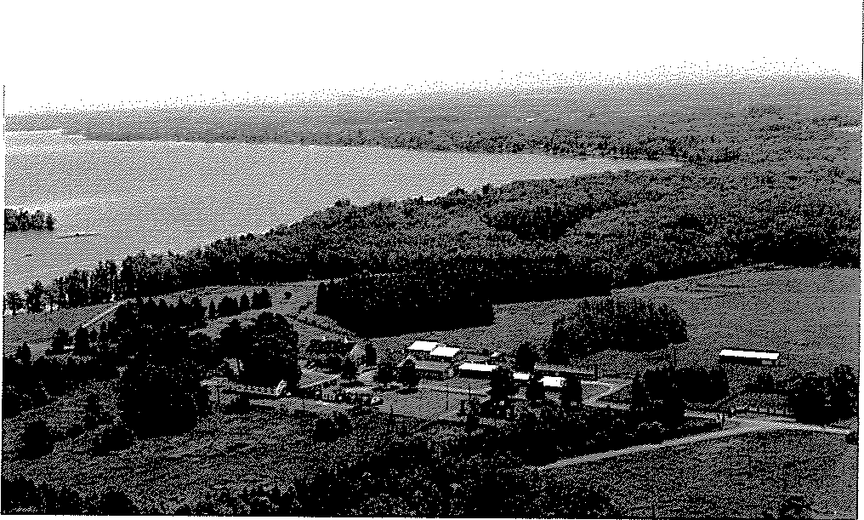

Fig.2.1. Cornell University Biological Field Station on Oneida Lake

a)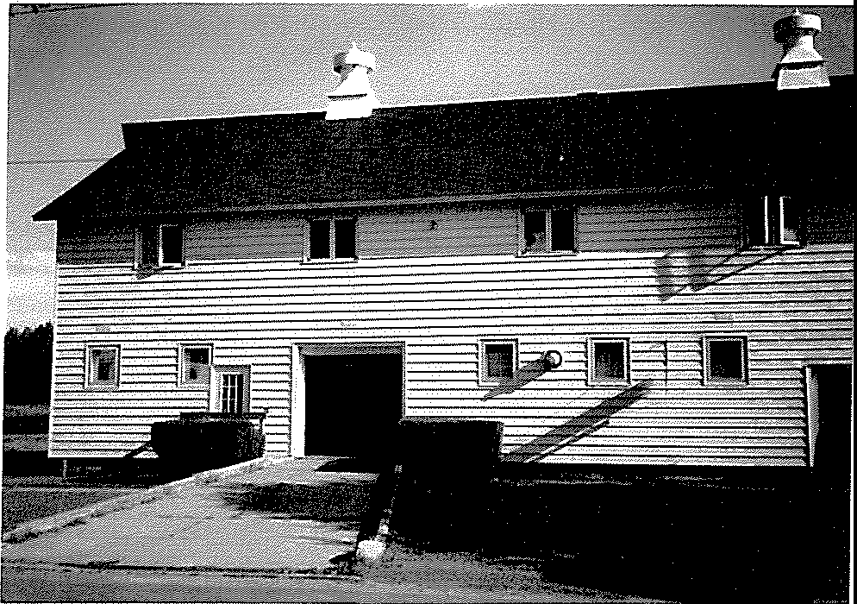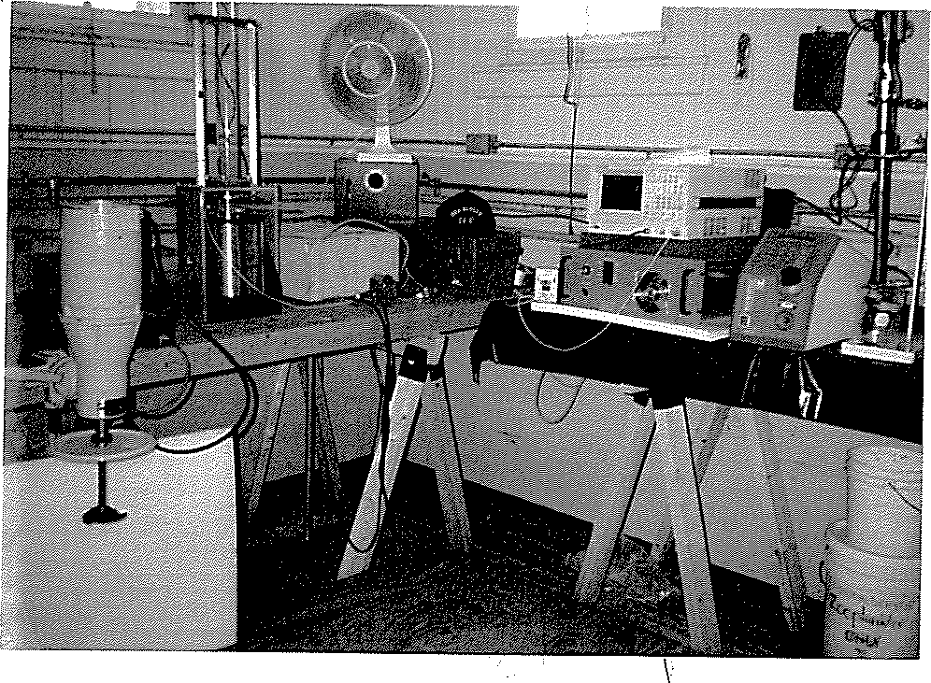

b)

Fig.2.2. Wet laboratory. a) building; b) one of the experimental setups

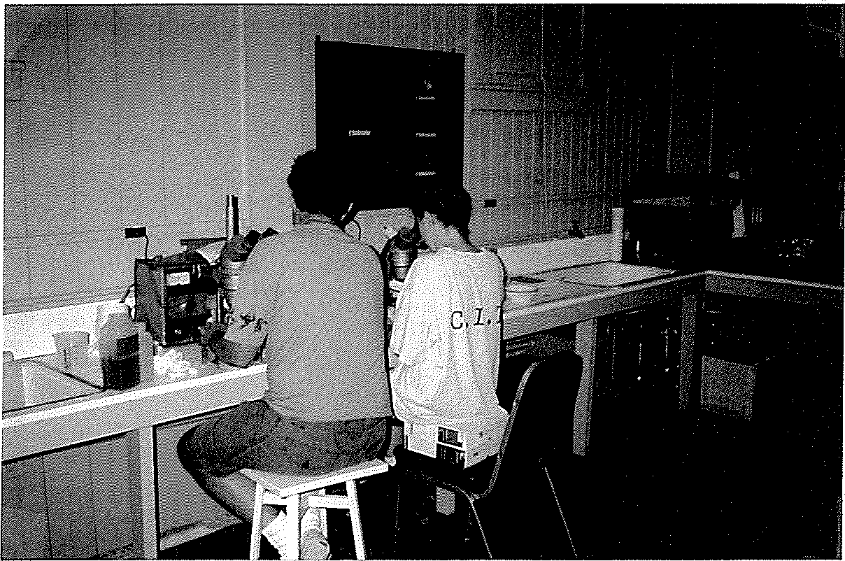

Fig.2.3. Dry laboratory

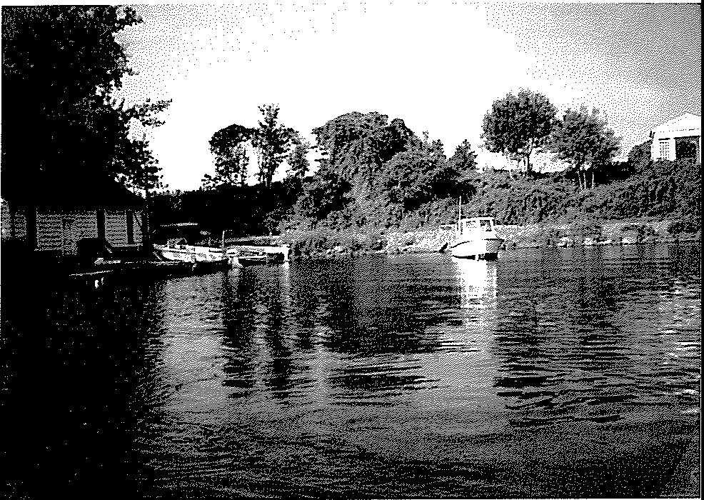

Fig.2.4. **Veliger collecting site**

plankton net samples (Fig.2.4). The station's boats were used for sampling of veligers, juveniles, and adult mussels in the vicinity of buoy 117 and at a sampling point east of the island. At the time of the experiments veliger density at buoy 117 was in the range 20,000 - 60,000 veligers per lcu.m.

### Sample Collection

Large-volume sampling of veligers was accomplished by two methods: pumping of water samples and multiple vertical plankton tows (Marsden, 1992). Plankton between 53 and 333µm was collected by pumping water with two submersible pumps through the plankton net with a 30cm diameter opening (53µm mesh) and next filtering the concentrated sample through 333 µm mesh. Water flow was calibrated and volume of pumped water was calculated during the collection. Because the depth in the area of the dock was about four feet, the amount of veligers there was limited, and sediments and sand contaminated the sample. That is why most of the time we used multiple vertical plankton tows. In addition, this method appeared to be more gentle to veligers: there were more moving veligers in the samples taken by this method. We used two plankton nets with a SO-cm-diameter opening (63 µm mesh) and mesh-lined plankton buckets with attached small lead weights to ensure rapid sinking of the net. The nets were dropped to 10 meters depth and were retrieved by pulling them vertically through the water column with a steady motion. We were able to obtain two cubic meters of water from each tow. Depending on the requirements of the test, we usually made 10-30 tows in one trip.

Small juveniles (l-4mm) were collected from the aquatic plants, while larger juveniles and adults were collected from rocks and shells of unionids on the bottom.

### Counting Procedure

The concentrated plankton suspension was normally diluted to 250 ml to prepare a stock solution. In order not to disturb veligers during additional concentration and dilution procedure, we used counting procedure for plankton tow (Marsden, 1992). We mixed the sample completely by swirling the testing jar or by inverting it 25 times to help insure uniform distribution of veligers. Then 1 ml of the sarople from the center of the jar was transferred with a Pasteur pipette to a Sedgwick-Rafter counting chamber with cover slip (McAlice 1971). We simplified the counting of veligers in the Sedgwick-Rafter cell by placing a grid under the cell so that the veligers were counted in smaller units. In order to increase counting precision, we counted 3-6 replicate subsamples in each test. To minimize variation among subsaroples, we tried to keep the density of larvae in our control sample in the range between 20 and 60 individuals per milliliter. To ensure reproducibility, we did our best to cany out all procedures precisely.

Veligers collected in Oneida Lake usually ranged from 100 to 300 microns. For observation and counting of veligers we used a zoom stereo microscope (Olympus SZ-Tr) with 40x and 80x magnification. For identification of veligers, we used photographs of *D.polimorpha* veligers at various life stages, as shown in Hopkins (1990) and Conn et al. (1993).

We used cross-polarized light to facilitate detection and identification of veligers. Cross-polarization was accomplished by using a microscope with a polarizing filter above and below the sample. One filter is rotated until the only light passing through both filters is that which is refracted by birefringent objects. Veligers are strongly birefringent due to the crystalline structure of the calcite in the larval shell which develops several days after fertilization. Thus the veligers look like bright spots against a dar·k background. More than that, because of the concentric arTangement of the crystals within the shell, veligers appear like glowing Maltese crosses (See Fig 2.B in Johnson, 1993). This feature sets bivalve veligers apart from all other similarly-shaped birefringent objects commonly seen in plankton samples. The only organism that could be mixed with zebra mussel veligers in cross-polarized light are ostracods, which also have calcareous shells. We used Ladd Johnson's description (Johnson, 1993) to avoid mistakes in

identifying of veligers vs. ostracods present in the samples from Oneida Lake. We believe that this teclmique is almost essential for the detection and enumeration of veligers in plankton samples and absolutely essential for identification of moving/non-moving veligers and establishing a dead/alive ratio.

We performed veliger count immediately after sampling, and before and after acoustic treatment; all visible organisms were counted and scored. 1bis is strongly advised while trying to differentiate living and dean animals (Cameron Lange, personal comm). Establishing a dead/alive ratio is a very difficult task, accomplished previously by very few biologists (Kilgour, Kepple 1993, Sonalysts, Inc. 1992). Usually organisms are classified as living if there is no visible shell or tissue damage, visible ciliary activity, or movement of gastrointestinal content. Dead larvae were classified as those not exhibiting movement, having cracked shells, and extruding soft tissue.

By Kilgour and Kepple (1993) there are four activity levels ofveligers:

1. Shell gaping and actively swimming = alive
2. Shell closed but ciliary activity obvious = alive
3. Shell closed and no activity= dead
4. Shell open and no response to prodding= dead.

Sonalysts and Aquatic Sciences (1992) generally observed four levels of effect:

1. None - no visible shell or tissue damage; continuation of ciliary activity after handling.
2. Slight - temporaiy closure and cessation of ciliaiy activity after transfer.
3. Moderate - visible cracking of shell, extrusion or dissociation of soft tissues.
4. Great - complete dissociation of shell and soft tissue; no identifiable anatomical parts at 40x magnification.

In this series of experiments we were looking for moving veligers versus those not exhibiting movement. We calculated the change in the number of moving veligers during the experiment

relative to the number of moving veligers in control as a response to acoustic and vibration exposure.

Statistical analysis has been made only when it appeared it would help in discerning differences in acoustic test effectiveness. In cases of obvious results (100% non-moving, or damaged veligers) or negative (no effect) statistic tests were not necessary. We chose distribution-free (nonparametric) techniques to evaluate probability in our tests, because it did not seem reasonable to use normality assumption in tests with small sample sizes (Devore and Peck, 1986). Contrary to the two-sample t-test, which requires specific assumption of (at least approximate) normality, the Wilcoxon Rank-Sum test states that the two population distributions have the same shape and spread. The only possible difference between the distributions is that one may be shifted to one side of the other. In these analyses, a lower-tailed test of the null hypothesis was made. The null hypothesis of no differences between means was tested against a difference between means greater than zero.

## HYDRODYNAMIC AND ULTRASOUND CAVITATION TEST

The objectives of this test were:

* To study the feasibility of using hydrodynamic cavitation to control zebra mussel veligers
* A detailed quantitative evaluation of cavitation effects and their energy consumption rates
* Comparison of the energy consumption efficiency of the hydrodynamic and ultrasound cavitation treatments

### Equipment

An off-the-shelf ultrasonic generator, "Sonicator XL2020," was used for ultrasonic cavitation tests. This device has a 550-watt acoustic power output on a frequency 20 kHz, programmable microprocessor, digital timer, and power output display. Figure 3.1 shows a picture of the device.

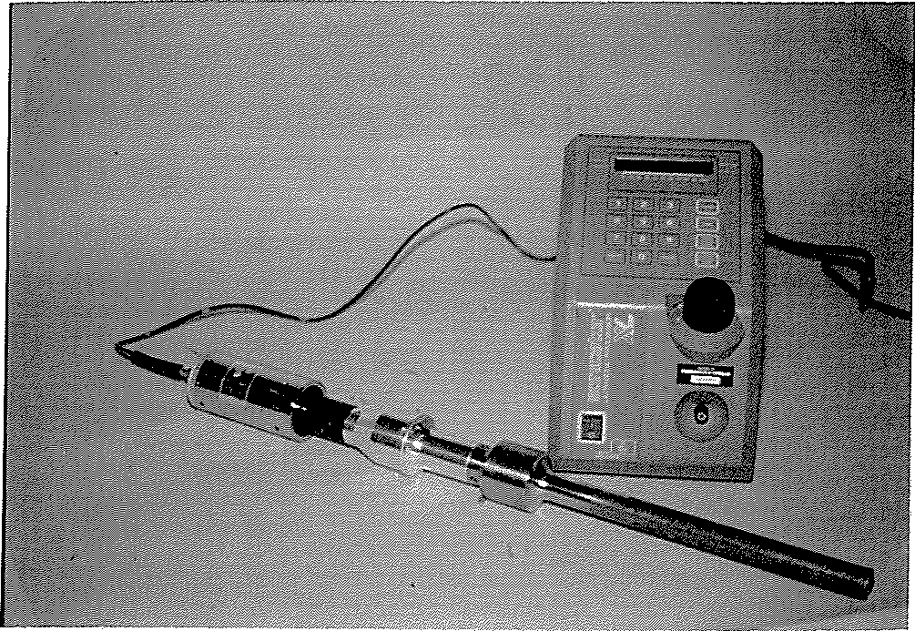

Fig.3.1 Ultrasonic cavitation device

For the hydrodynamic cavitation test, cavitation impellers (Fig.3.2a) were used. The impellers have three cavitating wedges ranging from 4 to 5.5 inches in diameter. The impellers were connected through a shaft to a variable speed 1/3 h.p. DC motor. The speed of the motor could vary from 900 to 4900 **RPM.** The assembled device (motor - shaft - impeller) is shown in Fig.3.2.b. A rotating impeller produced hydrodynamic cavitation in a closed five liter plastic container filled with water. In order to measure consumed and output power, a wattmeter was connected to the motor; thus, it was possible to measure consumed power with and without a load (water). The difference between these two measurement is the output power.

The spectra of noise produced by hydrodynamic and ultrasonic cavitation are depicted in Fig.3.3a and Fig.3.3b respectively. Noise from hydrodynamic cavitation is in a lower frequency range as compared to ultrasonic cavitation. This indicates that hydrodynamic cavitation generates bubbles having larger diameters, and therefore a stronger destructive effect can be expected.

### 3.2 Results of the Tests

***Ultrasonic caJ1itation***

**Test 1.** Measurements of zebra mussel mortality and the energy consumption rate vs. the cavitation intensity.

This ultrasonic cavitation test confirmed the results of the previous studies that cavitation kills veligers. New findings of this test reveals that the effectiveness of the ultrasonic cavitation treatment depends on the cavitation intensity. As Table 3.1 and Fig.3.4 indicate, the most effective treatment is achieved with the highest intensive cavitation (30 W/sq.cm). At this intensity, 100% mortality is achieved with *7.5kJ/liter* (7.9watt-hrs/gal) output energy rate.

a)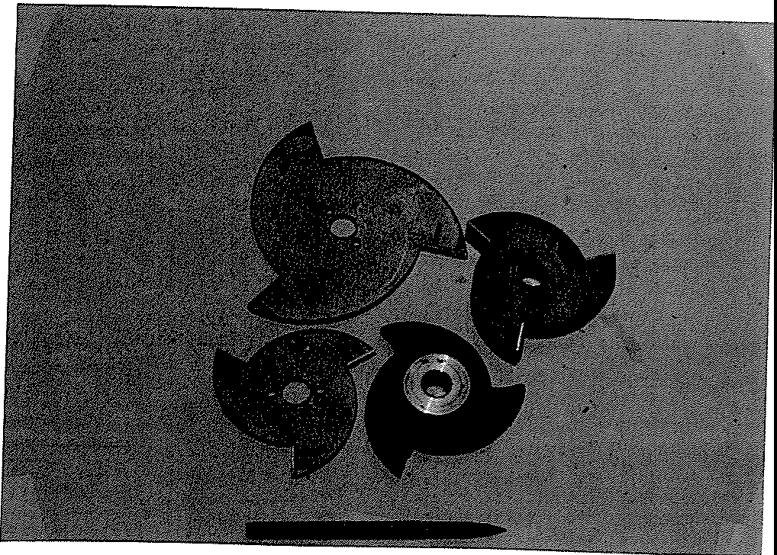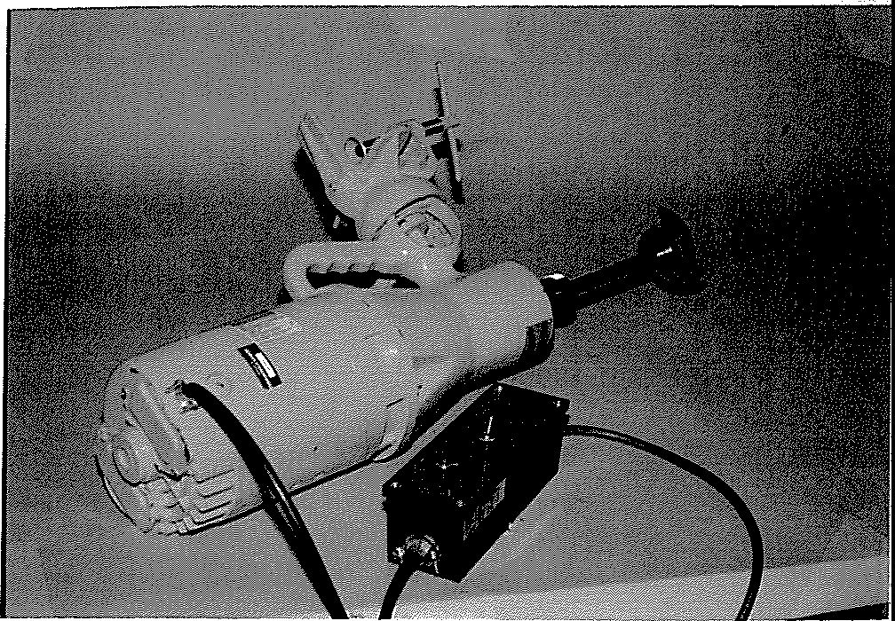

b)

Fig.3.2. Hydrodynamic cavitation device. a) cavitation impellers; b) assembled device

-70.00

SPECT PIJ,IER

dBUt'



-100.0 0.000 FREQ(Hz) 20.00k

-10.00

SPECT PIJ,IER

dBUt'

-70.00

Fig.3.3. a) Hydrodynamic cavitation noise spectrum (upper curve, 2200rpm = 37Hz). Low curve is ploted for 900rpm when was no cavitation. b) Ultrasound cavitation noise spectrum (20kHz).

Table 3.1. Ultrasonic cavitation treatment vs. cavitation intensity

| Treated Volume  (liter) | Output  Intensity (watt/sq.cm) | Time of treatment  (sec) | Output energy rate  (kilojoules/liter) | Mortality rate  (%) | Notes |
| --- | --- | --- | --- | --- | --- |
| 0.5 | 5 | 30 | 1.5 | 64 | shell fragments were observed |
| 0.5 | 5 | 60 | 3 | 82 |
| 0.5 | 5 | 120 | 6 | 95 |
| 0.5 | 10 | 25 | 2.5 | 71 | some shell fragments were observed |
| 0.5 | 10 | 50 | 5 | 78 |
| 0.5 | 10 | 100 | 10 | 91 |
| 0.5 | 30 | 5 | 1.5 | 64 |  |
| 0.5 | 30 | 15 | 4.5 | 82 |  |
| 0.5 | 30 | 25 | **7.5** | **100** | ahnost all veligers |
|  |  |  |  |  | were dissolved |

**Test 2.** Examination of a volume similarity effect

The objective of this test was to determine if the cavitation treatment has the same efficiency (output energy rate to achieve 100% mortality) for the various treated volumes. It is important to know in order to project results of this small scale experiment to a larger scale test. The results of the test are presented in Table 3.2.

The results indicate that 100% mortality in the different volumes are achieved with the same output energy rate. This means that the quantitative results of the tests may be applicable to an arbitrary volume to be treated.

100

90

Ul

I-

80

:,..

1-

:J

-,,: 70

0

60

##### so

5 10 15 20 25 30 35 40 45 *50* 55 60 *65* 70 75 80 85 90 95 100 105 110 115 120

TIME OF TREATMENT (sec)

Fig.3.4. Ultrasound cavitation test. Mortality rate vs. time of treatment for different output intensity levels.

Table 3.2. Result of ultrasonic cavitation treatment for different volumes

| Treated Volume (liter) | Output Intensity (watt/sq.cm) | Time of treatment  (sec) | Output energy rate  (kilojoules/liter) | Mortality rate (%) |
| --- | --- | --- | --- | --- |
| 0.1 | 30 | 1 | 1.5 | 68 |
| 0.1 | 30 | 5 | **7.5** | **100** |
| 0.5 | 30 | 5 | 1.5 | 77 |
| 0.5 | 30 | 15 | 4.5 | 94 |
| 0.5 | 30 | 25 | **7.5** | **100** |
| 1.0 | 30 | 25 | 3.75 | 87 |
| 1.0 | 30 | 50 | **7.5** | **100** |

***Hydrodynamic cavitation***

**Test 3.** Measurements of zebra mussel mortality and the energy consumption rate of hydrodynamic cavitation treatment

Hydrodynamic cavitation was achived with the speed of the cavitation impeller at 4700 rpm. In order to separate the cavitation effect from mechanical mixing of water with veligers, a measurements with the impeller speed of 900 rpm also were performed. At this speed neither cavitation nor mortality effect were observed. At the speed of 4700 rpm strong cavitation and mortality effects were observed. The result cifthe measurements is shown in Table 3.3.

Table 3.3. Result ofhydrodynamic cavitation treatment

| Treated  Volume (liter) | Number of impellers | Output Power  (watt) | Time of treatment (min) | Output energy rate  (kilojoules/liter) | Mortality rate  (%) | Notes |
| --- | --- | --- | --- | --- | --- | --- |
| 4 | **1** | 30 | 3 | 1.38 | 67 |  |
| 4 | 1 | 30 | 4 | 1.8 | 79 |  |
| 4 | 1 | 30 | 5 | 2.25 | 100 | shell fragments |
| 4 | 1 | 30 | 6 | 2.7 | 100 | shell fragments |
| 2.5 | 4 | 60 | 0.5 | 0.7 | 80 |  |
| 2.5 | 4 | 60 | 0.75 | 1.1 | 86 |  |
| 2.5 | 4 | 60 | 1 | 1.44 | 100 | shell fragments |

### Summary

1. For the first time it was shown that hydrodynamic cavitation can be used as a control measure for zebra mussel veligers.
2. The efficiency of the ultrasonic and hydrodynamic cavitation treatments were measured as an output energy rate (OER) to achieve 100% mortality (OER-100). The lower this number is, the more efficient is the treatment. It was found that the more intensive ultrasonic cavitation the more efficient is the treatment. It was also determined that hydrodynamic cavitation treatment was more efficient than ultrasonic cavitation: the OER-100 were 1.5 *kl/liter* (1.6 *watt-hrs/gal.)* and *7.5kflliter (7.9watt-hrs/gal.*), respectively for hydrodynamic and ultrasonic cavitation.
3. Measurements of OERs for various treated volumes showed that OER does not depend on the volume. Therefore, the obtained data may be used for designing a full scale test.

## VIBRATION EFFECT ON ZEBRA MUSSEL VELIGERS

The objective of this test was a study of survivability of pre- and settling stage veligers on a vibrating surface.

### Equipment and Methodology

A diagram and a picture of the experimental setup are shown in Fig.4.1 and Fig.4.2, respectively.

We mounted a vibrating platform driven by a vibrator at the bottom of a cylindrical glass vessel containing 0.5 liter of water with veligers as shown in Fig.4.1. The vibrator with a power amplifier (Vibration Test System, VTS-100) was able to operate in a frequency range of 20 to 16,000 Hz. Levels of vibration and sound field in the vessel were measured with a calibrated accelerometer (Dytran Instruments, model 3031A) and a hydrophone (Bruel&Kjaer, Model 8103), respectively. Signals from these sensors were depicted by a dual channel FFT sigual analyzer (Zonic A&D, Model 3525). The analyzer has a built-in sigual generator to control the vibration system

Duling the test, veligers in the vessel were in contact with the vibrating platform, as well as with the sound field radiated by the platform In order to separate the effect of vibration from sound radiation, a supplemental test was pe1formed in which veligers were placed into a sound-transparent rubber vessel suspended inside the glass vessel filled with water (Fig.4.3). All vibration and sound parameters, and duration of the treatment, in this test were the same as in the main test.

### Results of the Tests

Comparison of the main test (vibration and sound treatment) with the supplemental test (only sound treatment) showed that during up to 90 minutes of the treatment much higlier mortality rate

Water with veligers

FFT Analyzer

·-;··.····••.•.•.•··.·.·.·...•.,•··•.

Vibrating

;.•.

. . •.

\;:

platform Accelerometer

.,,,,.,.,",,','•""'",'.' ',,',',',,,

Fig.4.1. Diagram of the experimental setup to study the effect of sound and vibration on zebra mussel veligers

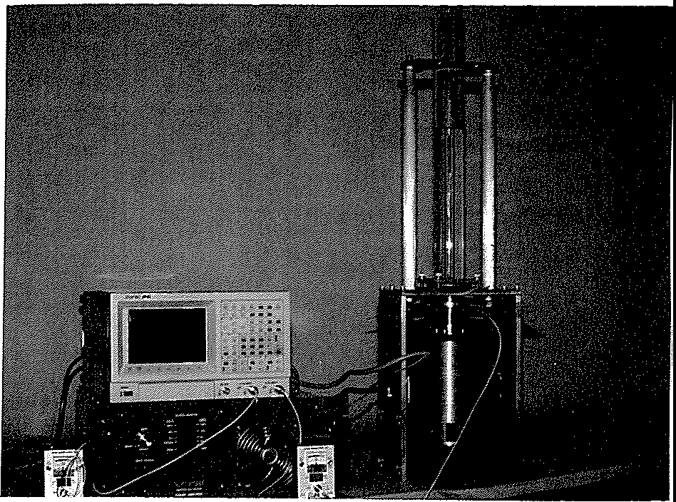

Fig. 4.2. Experimental setup for sound and vibration tests

Water

Water with veligers·---+-+

Vibrating platform

Glass vessel

-Hydrophone

,....,,._ Sound transparent container

Fig.4.3. Diagram of the supplemental test

were observed in the main test as compared with the supplemental test. Therefore, the mortality effect observed in the main test was caused mainly by vibration rather than by sound. The results of the vibration test are summarized in Table 4.1 and illustrated in Fig. 4.4.

Table.4.1. Result of vibration test

| Frequency (Hz) | Sound Level (dB re lµPa) | Vibration level (g) | Mortality rate(%) vs. Treatment Time (minutes) 15' 30' 60' 90' | | | |
| --- | --- | --- | --- | --- | --- | --- |
| 62 | 170-186 | 0.01 | 48 | 67 | 97 | 100 |
| 160 | 170-185 | 0.5 | 75 | 88 | 100 | 100 |
| 450 | 167-185 | 6 | 48 | 70 | 74 | 97 |
| 1,000 | 170-184 | 7 | 54 | 69 | 83 | 92 |
| 8,500 | 183-192 | 8 | 45 | 52 | 61 | 61 |
|  | 170-187 | 12 | 33 | 44 | 61 | 73 |
| 9,500 | 180-196 | 78 | 69 | 84 | 100 | 100 |
|  | 200-212 | 600 | 98 | 97 | 100 | 100 |
| 16,000 | 180-194 | 23 | - | 32 | 57 | 54 |

This test clearly indicates that low frequency vibration is a much more effective control measure than high frequency vibration.

1. **SOUND TREATMENT**

Objectives:

* To study the feasibility of detaching settled juveniles and adults
* To study the feasibility of preventing attachment of veligers and translocation of juvenile and adult mussels using low frequency sound
* To investigate behavioral response of adult mussels to sound
* To evaluate sound impact on mussel's reproduction

1

*';f?.* 8

!

*0*

'a

t:: 4

2

62 160 450

Frequency (Hz)

1000

8500 (min.)

Fig.4.4. Veliger mortality rate with respect to the :frequency and time of exposure

### Sound and Cavitation Detachment Tests

The sound detachment tests were performed with the same experimental setup as shown in Fig.4.1 and Fig.4.2. A fragment of a natural zebra mussel colony was placed into a glass vessel. During the test a juvenile colony (1 to 4 nun, Fig.5.1) settled on an aquatic plant and a juvenile -

adult colony (2 to 15 nun, Fig.5.2) settled on a unionid shell were treated with sound. Continuous

sound waves with :frequencies 78, 156, 685, and 1,000 Hz and sound pressure level 182 - 192 dB re 1 µPa were applied for up to six hours. No significant effects of detachment or mortality were observed.

Strong (30 w/sq.cm) 20 kHz ultrasonic cavitation treatment for up to 15 minutes on a natural colony of zebra mussels (Fig.5.3) also showed no significant effect.

These tests indicate that the control strategy must be rather preventive than destructive. Sound or cavitation, in practical amount, do not detach or kill juvenile or adult mussels. It is easy and cheaper to prevent attachment of the mussels rather than to destroy a settled colony.

### Adult Mussel Filtering Activity Test

The purpose of this experiment was to find a behavioral response (if any) of the adult zebra mussels to the variations in sound treatment (intensity, frequency, and duration of the treatments).

Filtering activity observations were performed with the same experimental setup as shown in Fig.4.1. A fragment of a natural zebra mussel colony (14 - 18 mussels) settled on a unionid shell (size class 11 - 17 mm) was placed into the glass vessel. At the start of each trial, the glass vessel was completely emptied, and then refilled with unfiltered lake water. In the beginning of trial, the colony was acclimated to the environment in the vessel for one hour, and then was treated with sound. Each trial lasted approximately 2 hours. In the first seconds of the expe1iment, and then every 5 -15 minutes, a :filtering frequency obse1vation was made, meaning that the number of

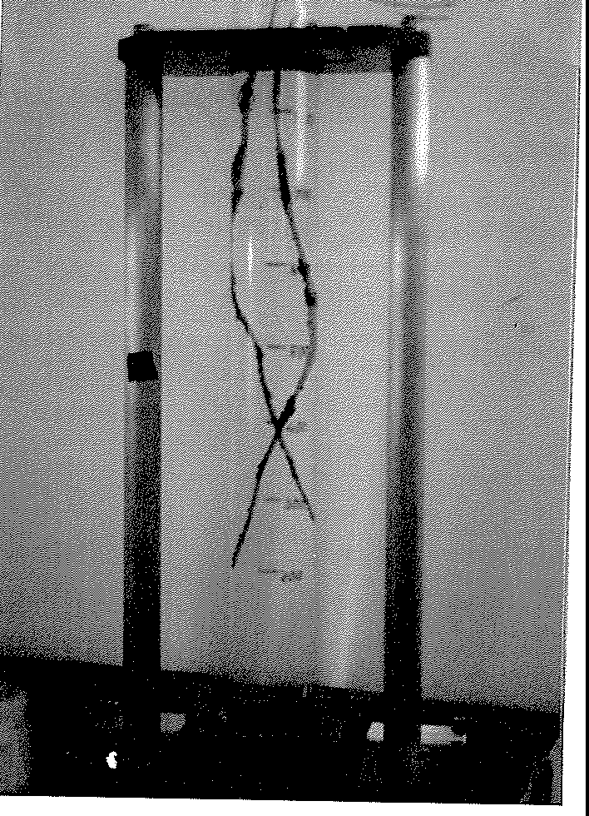

Fig.5.1. Sound treatment of juvenile colony settled on an aquatic plant

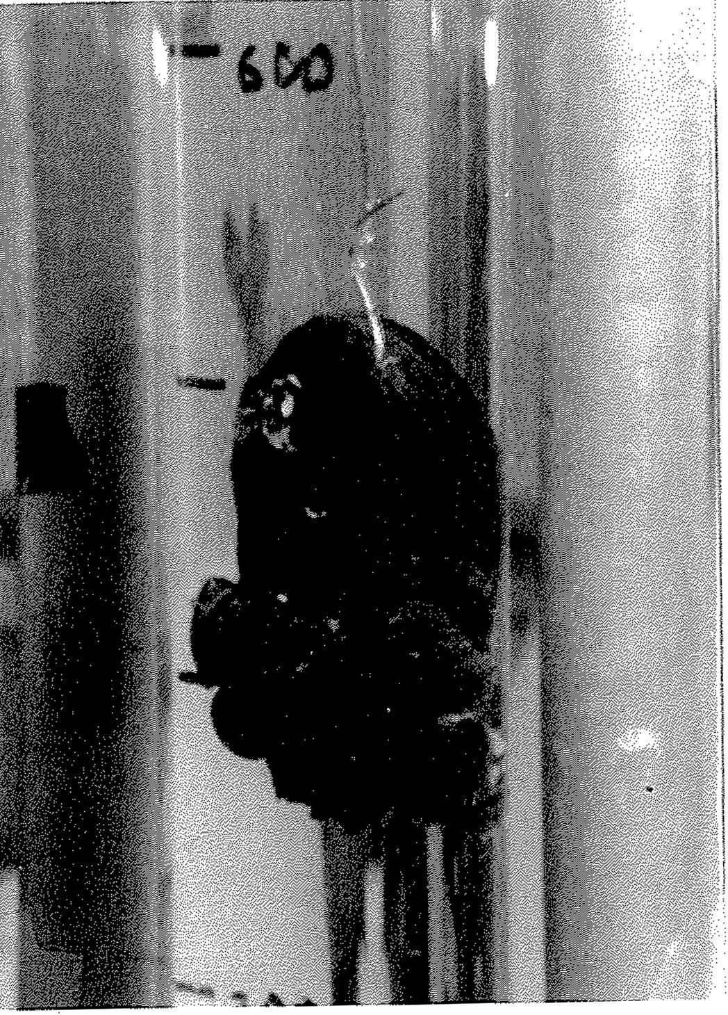

Fig.5.2. Juvenile - adult colony settled on unionid shell

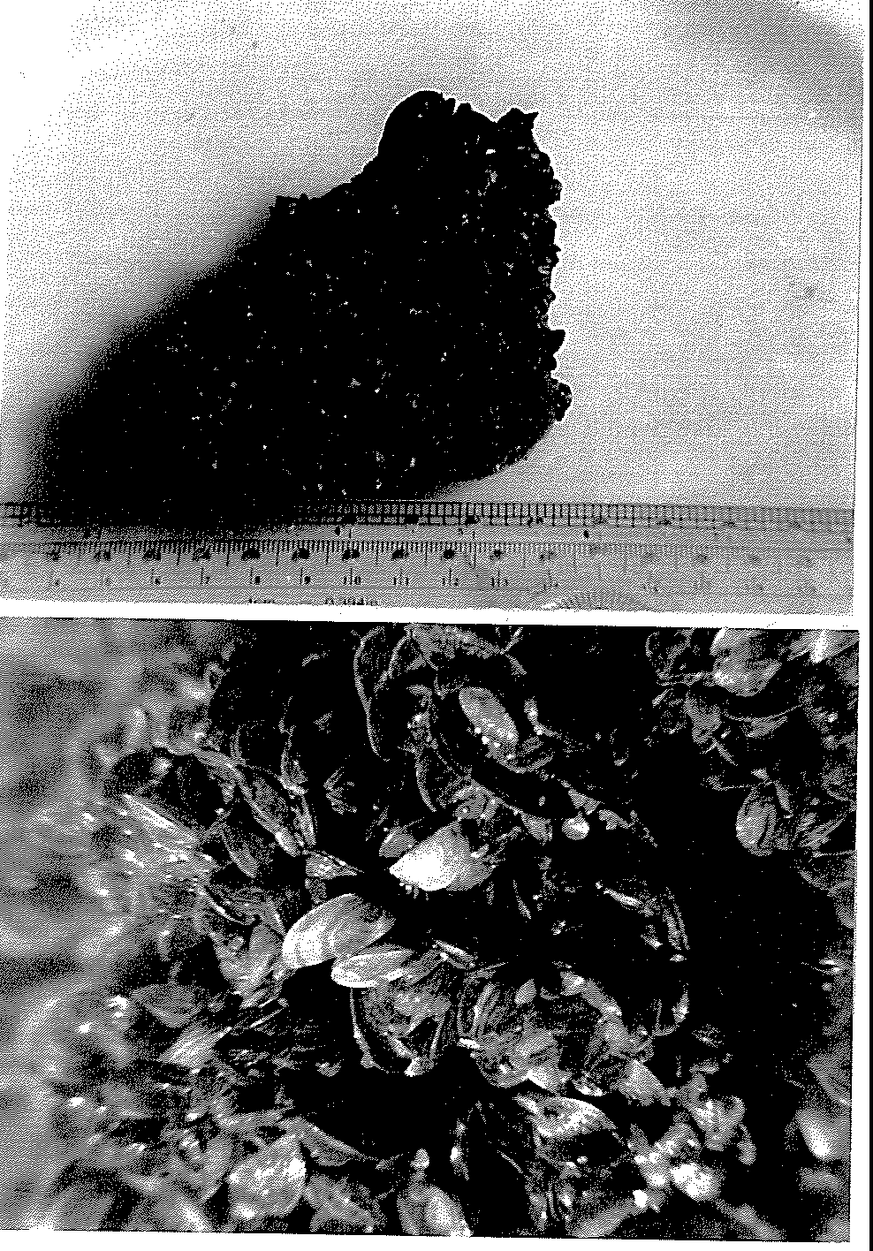

Fig.5.3.Anatural colony of zebra mussel treated with ultrasonic cavitation

mussels engaged in filte1ing water was recorded. We considered a mussel to be filtering if its valves (shells) were open and its siphon extended. A new group of mussels was treated for each change of acoustics parameters (frequency, mtensity, and pulsation).

At the start of each experiment, 90 -100% of mussels were actively :filtering. A significant reaction was recorded immediately after the beginnmg of treatment, with the mussels closing their valves. However, after their initial response to the sound, the mussels gradually became used to the treatment, and 15 - 45 minutes after the beginning of treatment, they resumed :filtering activity. We attempted to elicit responses by changing frequencies, mtensity of sound during the test, even by the use of pulsating sound having random frequency of repetition, but the mussels accustomed themselves to any of such a change.

From this mussel :filtering activity test, we conclude that sound treatment does not have a significant effect on behavior of adult zebra mussels.

### Sound Control of Juvenile and Adult Mussel Translocation

These tests were designed to study the effect oflow :frequency sound to prevent translocation and settlement of zebra mussels.

Two plastic tanks, each containing approximately 12 liters of fresh lake water, were usedm the initial experiment (summer of 1993). **On** the bottom of each tank a brick, a stone, a shell, a piece ofplexiglass, and a steel plate were placed. Approximately 10,000 zebra mussel juveniles (1 - 4 mm in length), collected from aquatic plants, were placed into the each tank. One tank was used for control, and the other one was sounded with 58 Hz, 170 dB re 1 µPa continuous sound during 12 hours. Sound was generated with a vibrating aluminum bar. The bar was placed in the center of the tank and was exited with an electric vibrator (Branford Vibrator Co., Model HS-1) as shown on the diagram in Fig.5.4.

Table

Fig.5.4. Mussel translocation test - 1993. Diagram of the experimental setup

After the test, the number of attached mussels in the treated and the control tanks were counted. The result is shown in Table 5.2.

Table 5.2. Number of attached mussels in treated with sound and control tank

|  | Number of Attached Mussels | | | | | |
| --- | --- | --- | --- | --- | --- | --- |
| Taruc wall | Brick | Stone | Shell | Plexiglass plate | Steel plate |
| Treated Tank | 12 | 17 | 5 | 5 | 2 | 1 |
| Control Tank | 220 | 180 | 380 | 360 | 98 | 36 |

Reduction of the attached mussels in the treated tank as compared to the control tank was 97%. This result indicates the feasibility of low frequency sound control of zebra mussel translocation. The use oflow frequency sound as a control measure is very attractive because such waves can sound significant areas and volumes with little power consumption.

In order to investigate effect of low frequency sound in greater detail, the more studies were undertaken in larger scale, using various frequencies and sound levels. Tests were performed in the three cubic meter tank with flow-through raw water pumped directly from Lake Oneida (Fig.5.5). On the bottom of the tank various objects (bricks, a concrete block and a plate, and a steel pipe were placed. A source of low frequency sound was installed in the water column (Fig.5.6). An electric concrete vibrator (Dreyer Vibrator Co., Model QE) were modified and used as a source of sound. A cylindrical vibrator head (2.5 inch diameter, 14 inch long) was driven with a rotating eccentric mass, placed inside the head. The mass was rotated with a 2.5 h.p. electric motor through a flexible shaft. The speed (frequency) of rotation was controlled with a specially fabricated controller. A picture of the vibrator and the controller shown in Fig.5.7. The sound pressure level was measured with calibrated hydrophone (Bruel&:lqaer, Model 8103) in 24 different locations 2 cm above the bottom of the tank and then was averaged for each test.

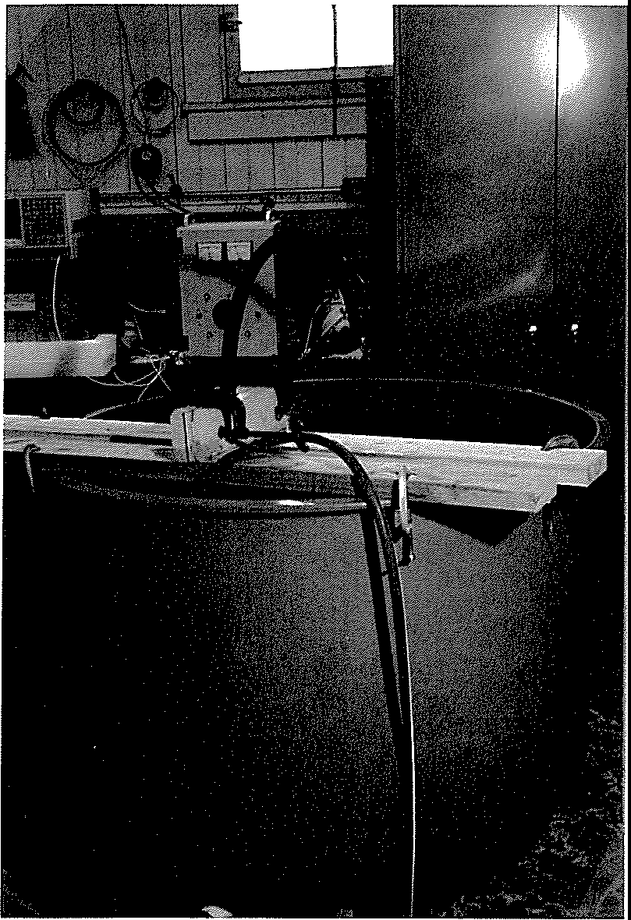

Fig.5.5. Low frequency sound test. Experimental setup

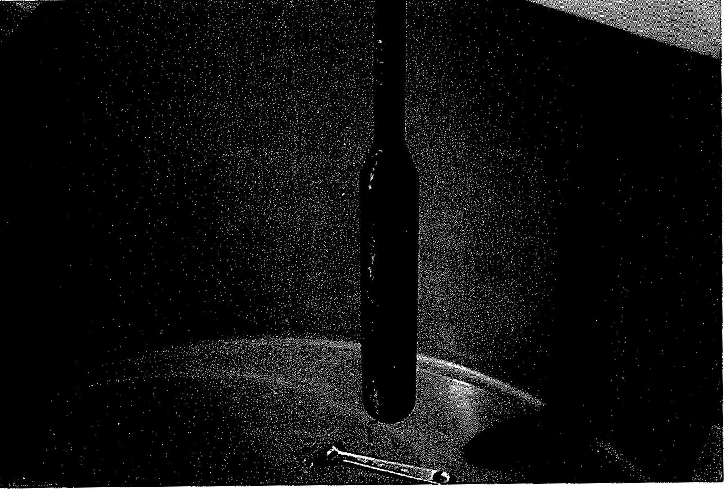

Fig.5.6. Low frequency sound test. Vibrating head of sound source

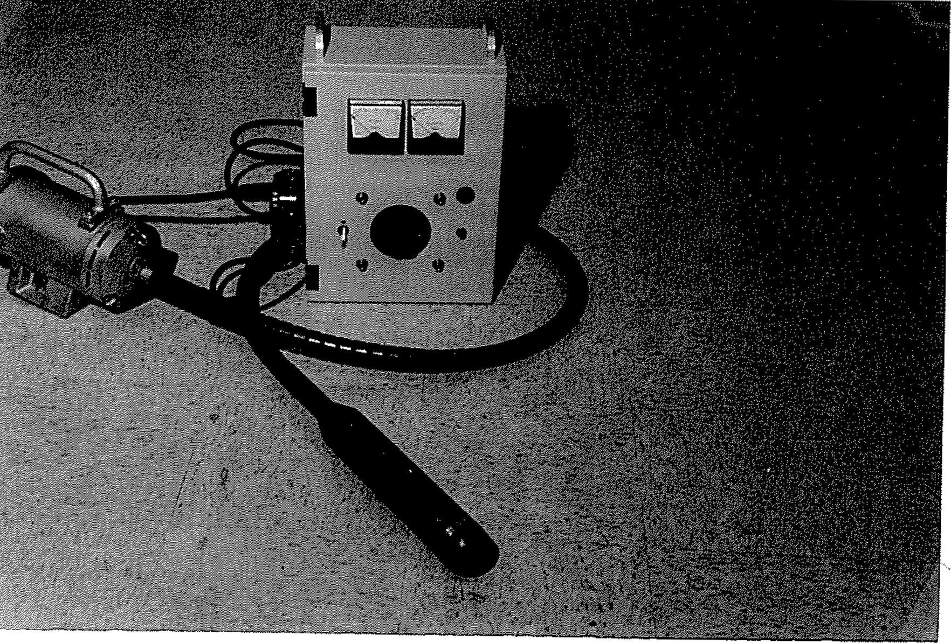

Fig.5.7. Low frequency sound test. Sound source and controller

42

Approximately 10,000 mussels ranging in size from 1 mm to 25 mm were positioned on the bottom ofthe tank (Fig.5.8). In each test a fresh portion of the mussels was used. Mussels were collected from natural colonies settled on rocks and unionid shells. Mussel size distribution is shown in Fig.5.9. Gray column indicates size distribution of mussels placed on the bottom ofthe tank at the beginning of the test. Black column indicates size distdbution of mussels settled (translocated) onto the tank wall, bdcks, and the other objects in the tank 24 hours latter. This chru.t shows that juvenile and adult mussels with the size up to 15 mm are equally active in translocation. No translocated mussels having size greater than 15 mm were observed in the tests.

Observation of mussel translocation and settlement with time in control tests shows that 92% of mussels translocate within first 12 hours after initiation of the test (Fig.5.10). Therefore, taking into account the day/night cycle and its possible influence on mussel activity, the chosen 24 hour duration of the tests was enough to study sound effect on mussel translocation.

Sound treatment tests were performed with vadous :frequencies (in the range 37 - 130 Hz) and sound level (50 to 315 Pa) for 24 hours. The mussel translocation rate were observed in both control (no sound treatment) and under the treatment. Significant reduction (93% at average sound level 315 Pa) in the mussel translocation rate in treated vs. untreated tests was obse1ved, as illustrated in Fig.5.11 - 5.12. In addition, the attachment of mussels under sound treatment was much weaker as compared with mussel attachment in control tests.

In the course of the test with the loudest sound (315 Pa, 110 - 130 Hz), eve1y three hours we counted mussels settled (translocated) onto the tank wall during 24 hour sound treatment and 24 hours later (Fig.5.13). Under the sound treatment a small number of mussels translocated and settled on the tank wall during the first 12 hours. For the next 12 hours of treatment no mussel translocations were observed. After halting the sound, mussels resumed their translocating activities. The number of settled on the wall mussels increased in more than 5 times for the following 24 hours, indicating that most of the mussels were alive but their translocating ability were suppressed during the sound treatment.

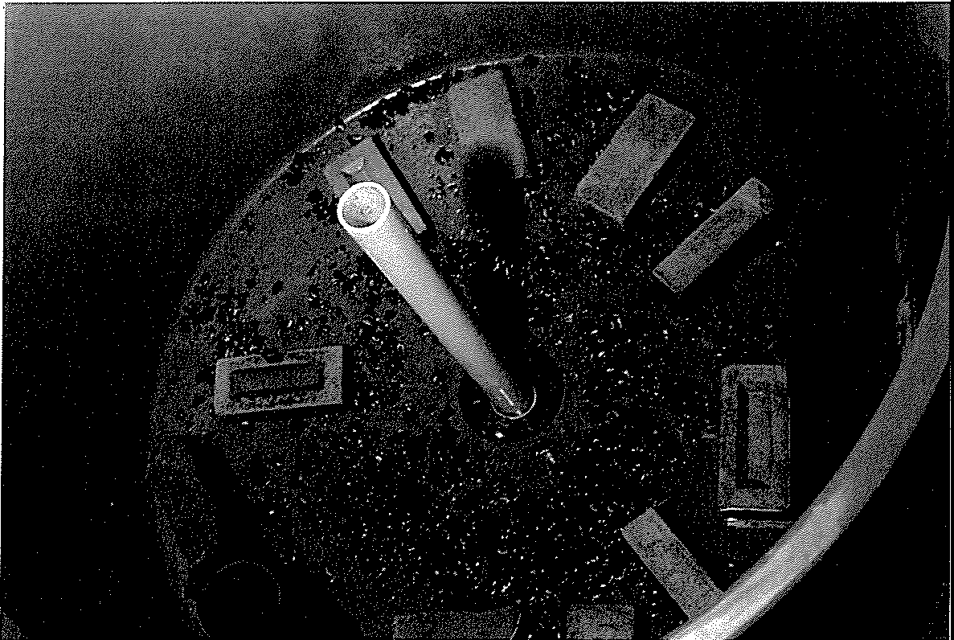

Fig.5.8. Low frequency sound test. Dislocation of mussels on the bottom of the tank

100

,-. 80

Cll

Q)

Cll

60

4-<

0

40

z

20

0

<5 5 -10 10- 15

Mussel Size (mm)

15-20 >25

Fig.5.9. Low :frequency sound test. Mussel size distribution.

Gray column - number of mussels placed on the bottom of the tank at the beginning of the control test, black column - number of mussels settled on the tank wall and other objects after .24 hours

._,,

'o"''l

100

80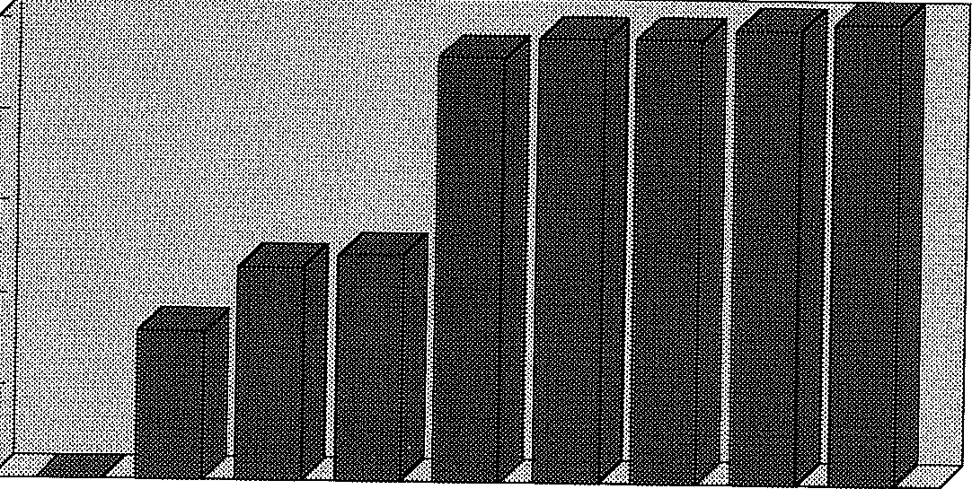

"' 60

'El

:;; 40

1z

20

0

0 3 6 9 12 15 18 21 24

Tnne (Hours)

Fig.5.10. Mussel translocation rate vs. time in control test

**C/l**

**11.)**

,.c

900

800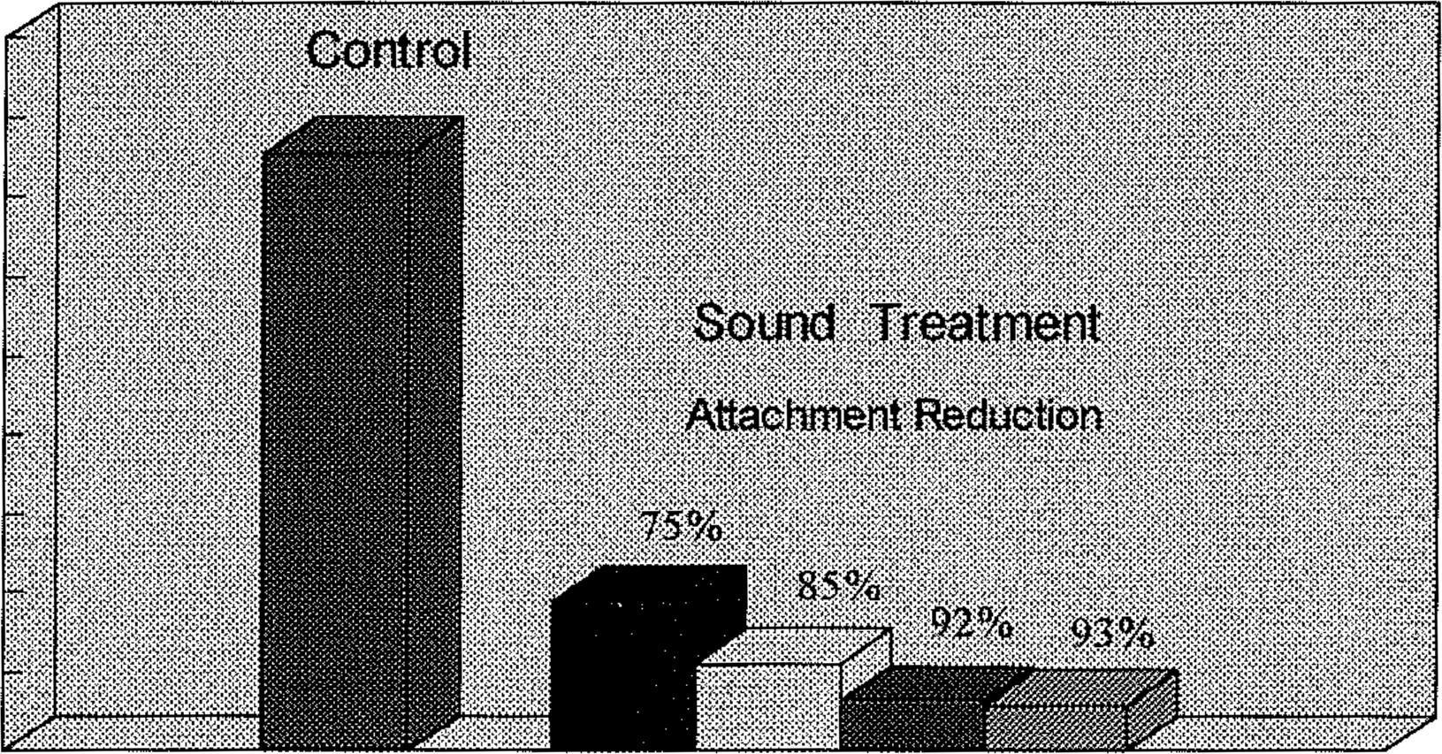

700

600

500

@ 400

300

F< 200

100

0 0 50 100 250 315

Average Sound Level (Pa)

Fig.5.11. Total number of attached mussels in control and under the sound treatment with various sound levels

47

**100**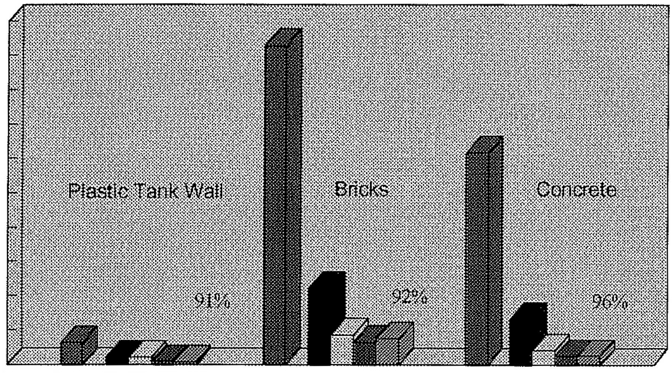

**90**

*ci* **80**

ii0.

"'

z

**70**

| 60 |  | | | | | |
| --- | --- | --- | --- | --- | --- | --- |
| **50** |  |  |  |  |  |  |
| 40 |  |  |  |  |  |  |
| **30** |  |  |  |  |  |  |
| **20** |  |  |  |  |  |  |
| **IO** |  |  |  |  |  |  |
| **0** | **0** | **50 100 250 315** | **0** | **50 100 250 315** | **0** | ***50* 100 250 315** |

Average Sound Level (Pa)



##### Fig.5.12. Number of attached to various materials mussels in control (no sound) and under sound treatment

48

t/l

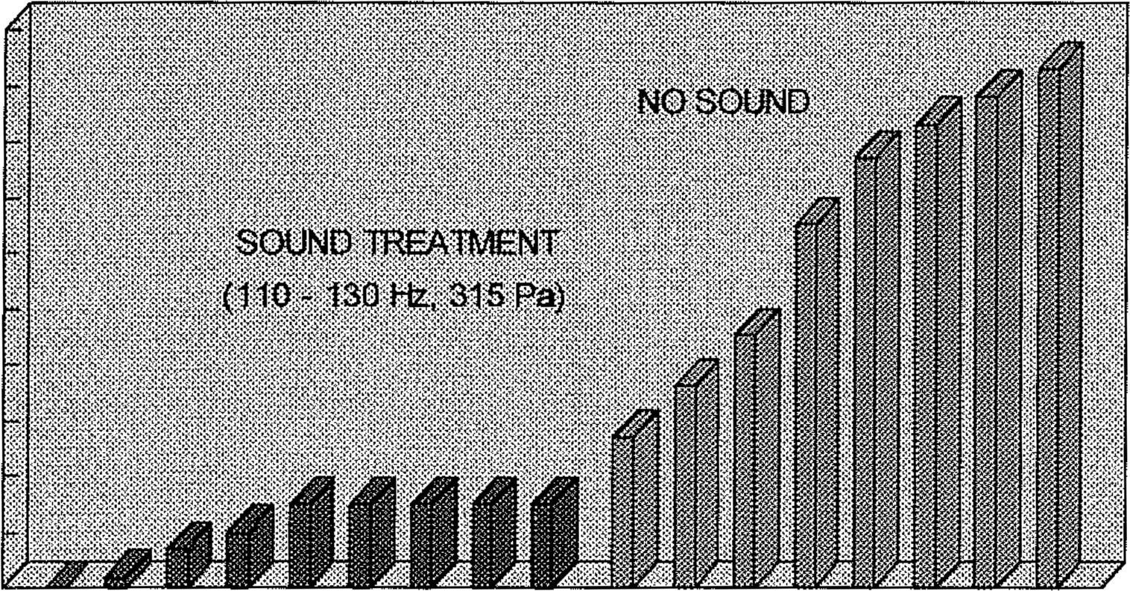

80

Q)

<ll

t/l

60

4-<

0

lo..

(I)

.21

0

Time (Hours)

Fig.5.13. Number of attached mussels vs. time during 24 hour sound treatment and 24 hours later

49

#### Effect of Sound on Veliger's Settlement Abilities

This study was undertaken with collaboration with the Triton Tbalassic Technologies, Inc. (Ridgefield, CT) and conducted at the Chasapic Biological Laboratory, University of Maryland (Solomons, MD).

The objective of this test was to determine sound impact on veliger's ability to attach to hard surfaces, such as concrete walls, exposed to sound. The same equipment as in previous experiment, (Fig. 5.7), was used. Two cement building blocks and the sound source were suspended in the 18" square by 7' long :fiberglass tank :filled with water as shown in Fig.5.14. Free swimming veligers (pre-settling stage) were placed into the sound transparent nytex screen houses surrounding the blocks. These screens allowed us to keep veligers in the vicinity of the blocks, feed them, and prevent them from direct contact with vibrator and vibrating tank walls, so the effective control of settlement on the blocks could be exercised. Water in the tank was kept at a constant temperature during the entire experiment. Low water flow provided within the tank assisted veligers in locomotion inside the screen houses. Similar setting was arranged in the control tank.

Acoustic sound pressure (measured at the blocks) during this experiment ranged from 170 dB to 180 dB re I µPa (315 Pa to 1000 Pa respectively), depending on the location of the various block surfaces. The experiment with continuous sound radiation lasted for 14 days. This was enough time for the settlement of the veligers. After the first five days of the treatment there were no viable veligers detected in a water sample taken from one of the screen houses, while veligers were active in the control setting. After 14 days of exposure no mussels counts were done because of the presence of sand (eventually removed from the cement blocks) made it impossible to account for all the mussels.

In order to evaluate the results ofthe test, the blocks from the control and treated settings were removed, lightly washed down, placed in clean water, and fed for an additional week. Bleach was added to kill mussels, settled on the blocks, to cause their removal from the block surfaces such

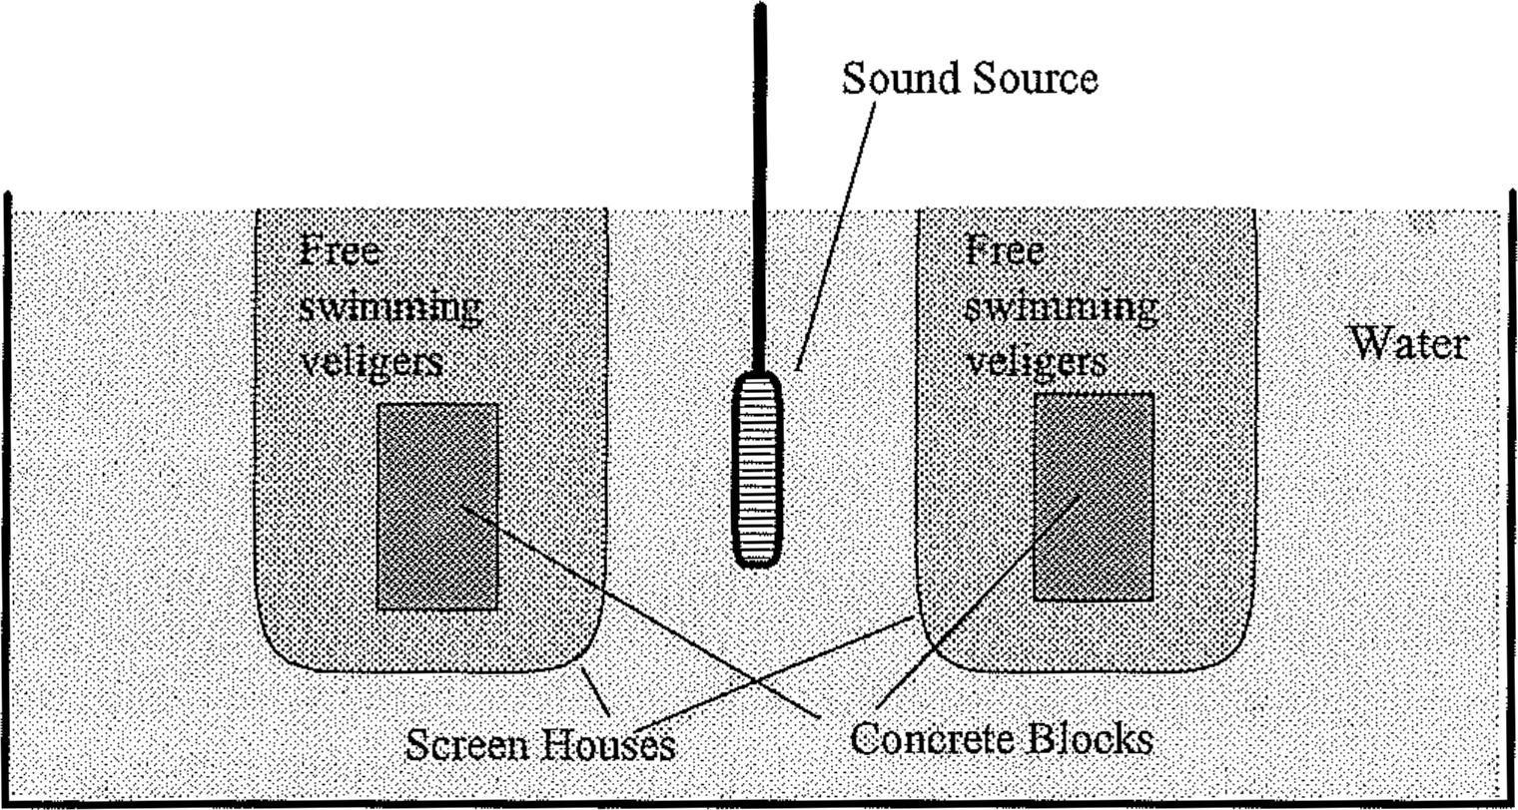

Fig. 5.14. Sound impact on veliger's settling ability. Block-diagram of experimental setup.

that only remnants of settled mussels were observed. The results indicated viable settled mussels on the control blocks, but none on the subject blocks. Average size of mussels settled on the control block was 330µm. This size data represents an accurate determination of “life cycle” development at the time of measurements (settlement typically begins when mussels reach approximately 200µm).

* 1. **Effect of Low Frequency Sound on Spawning and Reproduction** in **Dreissenid Mussels**

The experiments, first of this kind, were conducted in Chasapic Biological Laboratory, University of Maryland, at Solomons, MD, in collaboration with Dr. David A Wright. The same sound source, as shown in Fig.5.7. was used in this study.

Adult Dreissena bugensis were conditioned to reproductive maturity by maintaining at 10 C on a daily diet of *Chlorella sp.,* Isochrysis galbana, and Neochloris sp. Eighty adult D. bugensis were taken from 10 C, scrubbed of debris, and placed in a 5ml/L bleach (5.25% sodium hypochlorite) solution for five minutes to destroy any protozoans. The mussels were rinsed with deionized water for five minutes to remove bleach residues and placed into a polycarbonate container filled with SL of 22 C culture water. After thirty minutes, the water was replaced with fresh culturn water and 60 C cultuTe water was added to increase the tempernture to 24 C. Within ninety minutes, five males and five females were spawning. Twenty five random animals were placed into the exposure chamber and control chamber (80 L culture water in a 110 L polypropylene trash can). The sound device was turned on just before addition of animals. Sound pressure level was not higher than 300 Pa at frequency 120 Hz.

Two hours after the addition of animals, the sound was turned off and water checked for gametes. Animals in the exposure chamber did spawn and after two hours, 12% of the eggs were fertilized. Another hour after the sound was turned off: 78% of the eggs were fertilized. A total of 323,000 eggs were spawned.

Animals in the control chamber also spawned. However only 68,000 eggs were produced. One hour after the sound was turned off in the exposure chamber, the control fertilization rate was 47%.

It is possible that the higher temperature (due to heating by the sound device) in the exposure container induced more animals to spawn sooner. The water temperature of the control chamber was 21 C while the exposure chamber was 26 C.

Another experiment was conducted with higher sound level (up to 1000 Pa). Spawning was induced as in above spawning experiment. When an animal was seen spawning, it was removed from the spawning chamber, rinsed, and placed into a separate 400 ml beaker filled with 300 ml culture water. We used five females and six males. Prior to mixing of eggs and sperm, the eggs were checked for the presence of sperm and/or fertilization. At that time, no sperm was present in any of the containers with eggs and there was no fertilization. Eggs were pooled into a 4 L beaker and sperm pooled in a separate 4 L beaker. The sound device was turned on. Eggs were poured into the exposure and control chambers (50 L) followed by sperm a few seconds later.

Ninety-five minutes after the sound exposure, 12 L of water was poured through a sieve and eggs checked at this time. 7% of the eggs were fe1tilized and the rest were intact and appeared unharmed. Ice was added to the chamber to b1ing the temperature back down to 23 C (from 28 C reached dming this test). The sound was turned on after ten minutes and eggs were checked again after an additional forty minute exposure. No eggs were present at this time. The control fertilization rate was 43% after 135 minutes.

We were surprised by the enhanced spawning pe1formance in the presence of sound. This can be explained by the temperature differential between the exposure and the control container and that the conditioning process in conjunction with the increased temperature of the sound chamber more than offset the potentially inhibitory nature of the acoustic vibrations whether directly through the water or as induced in the walls of the container (the animals were placed directly on the bottom of the polypropylene container which was being vibrated by the sound waves). An

alternative explanation is that the actual acoustic vibration itself was responsible for increased release of eggs. The differential spawning was not truly quantitative (3.23 x 10 vs. 6.8 x 104) because spawning between individuals can, in any case, be highly variable. Nevertheless, given that the numbers of individuals in the experimental and control batches were equal, the clifferent sizes of the spawns do indicate at least qualitative differences. We therefore conclude that the presence oflow frequency sound is non-inhibitory to the spawning of well-conditioned dreissenid mussels and may even enhance the process. We also noted a dramatic increase in spawning once the sound was shut off (78% vs. 47% in controls) which may also have been due to increased temperature.

In spite of increased spawning, fertilization rate was significantly reduced in the present of sound. The fertilization rates seen in the presence of sound in both experiments (12% and 7% in sound vs. 47% and 43% in control settings respectively) clearly indicate that fe1tilization is substantially inhibited, but not eliminated, in the presence of low frequency sound. Note that the second experiment was conducted at a higher sound intensity than the first.

Notwithstanding the differential fertilization rates it is clear that two hours exposure to low frequency sound (at least when applied at the higher intensity) is incompatible with egg or emb1yo survival. After exhaustive sieving and searching of all the water in the second expe1iment we can only conclude that all developing eggs and embryos were completely destroyed by acoustic energy at some time following the first obse1vation (i.e. between l-2h sound exposure).

* 1. **Impact of Sound on Non-Target Organisms**

In parallel to main tests with zebra mussel juveniles and adults, we also experimentally tested the response of natural phytoplankton and zooplankton to low frequency sound. Natural phytoplankton consisted of four major representatives of blue-green algae (at the time of experiments the lake water was blooming with blue-green algae): Anabaena flos-aquae, Gomphosphaeria lacustris, Microcystis aeruginosa, and Aphanisomenon :flos-aquae. Natural zooplankton was represented by two species of Dapbnia (D. galeata mendotae and D. pulicaria)

54

and two species of calanoid copepods (Leptodiaptomus sicilis and L. minutus). We also tested a behavioral response of young yellow perch to low frequency sound. These experiments were designed to study the effects of low-frequency sound on natural aquatic inhabitants. The experiments were not aimed at an in-depth investigation of impacts on biological functions of aquatic organisms, such as reproduction, photosynthesis, respiration, etc. We observed the direct effect of sound on organism's structures, their behavior and mortality comparatively to the control (no sound) test.

Phytoplankton and zooplankton were collected with a vertical net tow (a 0.5-m plankton net equipped with 153-um mesh netting) in 10 m of water from Oneida Lake, New York. During the experiments phytoplankton, Daphnia, and Copepods were kept separately in 250 ml clear plastic (PET) bottles with 58 µ.m mesh netting windows. All bottles were placed in a large mesh bag that contained a float and ballast. The mesh bag was suspended in the tank with Dreissena community at a depth of 0.1-0.2 m . The bag containing the bottles was neutrally buoyant and transparent to low-frequency sound so that the vibration of the water due to sound carried motion to the bottles content.

We did not find any difference in the structure and behavior of tested organisms during sound treatment and control. In both cases the structure of algae did not change visually, Daphnia showed approximately 10% mortality in both tests, while copepods showed mortality about 30-40%. It seems that some conditions in experimental set-up were not favorable for copepods both in control and test. The behavior of the yellow perch in the test and during the following five days was practically adequate to its behavior in control. From these tests we make a preliminary conclusion that low-frequency sound does not have a negative impact on structures, behavior and mortality of aquatic organisms. Still more complex experiments should be done in order to confirm this conclusion.

**5.6. Discussion**

The conducted studies demonstrate that low frequency sound can be effective control measure of zebra mussel fouling. Waterborne low frequency sound prevents veligers, juvenile and adult mussels from settling and translocating onto exposed surfaces. This effect was found to be most virtuous in a low frequency range (below 200 Hz). We explain tbis preventive (not destructive) effect as result of combined action of sound and vibration. Waterborne sound along causes no direct harm to adult mussels as well as to others non-target aquatic organisms. However, the sound excites slight vibration of exposed structures and mussels avoid settling and translocating onto these vibrating surfaces. Note, that significant preventive effect was achieved for low level of sound and sound exited vibration. 93% of mussel settling reduction was achieved for sound level 315 Pa (170 dB re lµPa). In addition to tbis preventive effect, low frequency sound inhibits mussel's fertilization and make eggs and veligers inviable.

7. **ULTRASOUND EVALUATION OF ZEBRA MUSSEL POPULATION**

*Ibis* study was aimed to develop an ultrasound technique for remote evaluation of zebra mussel population growing on the walls of water intake and storage facilities. Pictures and a diagram of the experimental setup are presented in the Figures 6.1, 6.2, and 6.3. A pair of ultrasonic emitter and receiver were suspended in 3 cub.meter water tank and directed toward the bottom of the tank. Mussels ranging from 2 to 25 mm (Fig.6.3) were placed on the concrete plate 0.5 m beneath the ultrasonic transducers. The effect of mussel on the amplitude of the reflected ultrasonic pulses were examined with respect to mussel surface density and the central frequency of the pulses. Without mussels, emitted signal mostly reflects from a smooth surface and goes to a receiver. With mussel mterventi.on, the surface becomes rough and scatters part of the acoustic energy m arbitra1y directions, so less energy reflects toward the receiver. Mussels may also absorb some acoustic energy, :further reducing the reflected signal. The more mussels on the swface the greater the scattering and absorbing effect. Therefore, this effect can be used for evaluation of zebra mussel population.

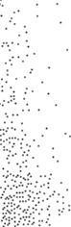

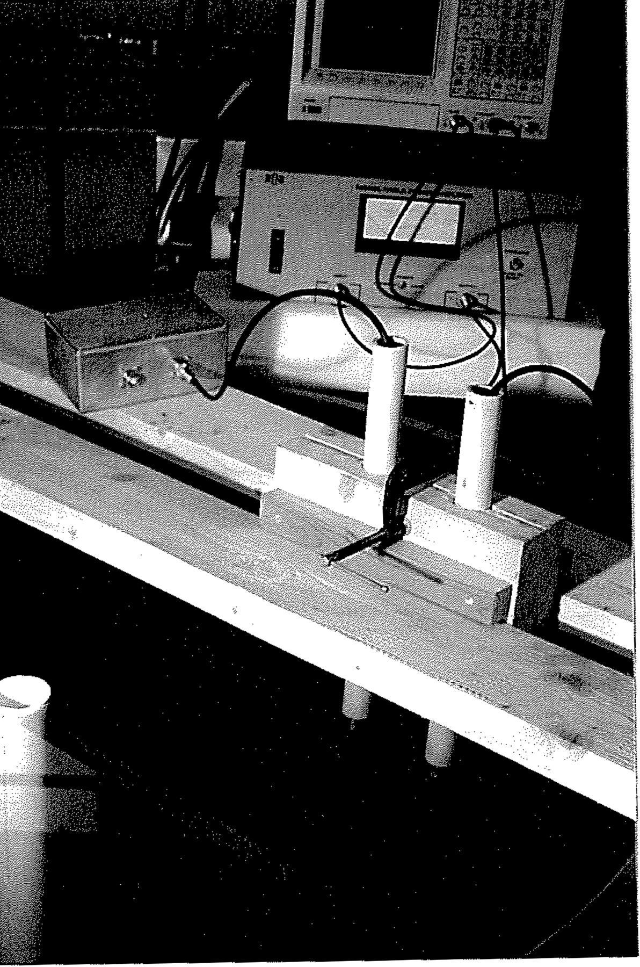

Fig. 6.1. Ultrasound detection of zebra mussels. Experimental setup.



Fig. 6.2. Ultrasound detection of zebra mussels. Diagram of experimental setup

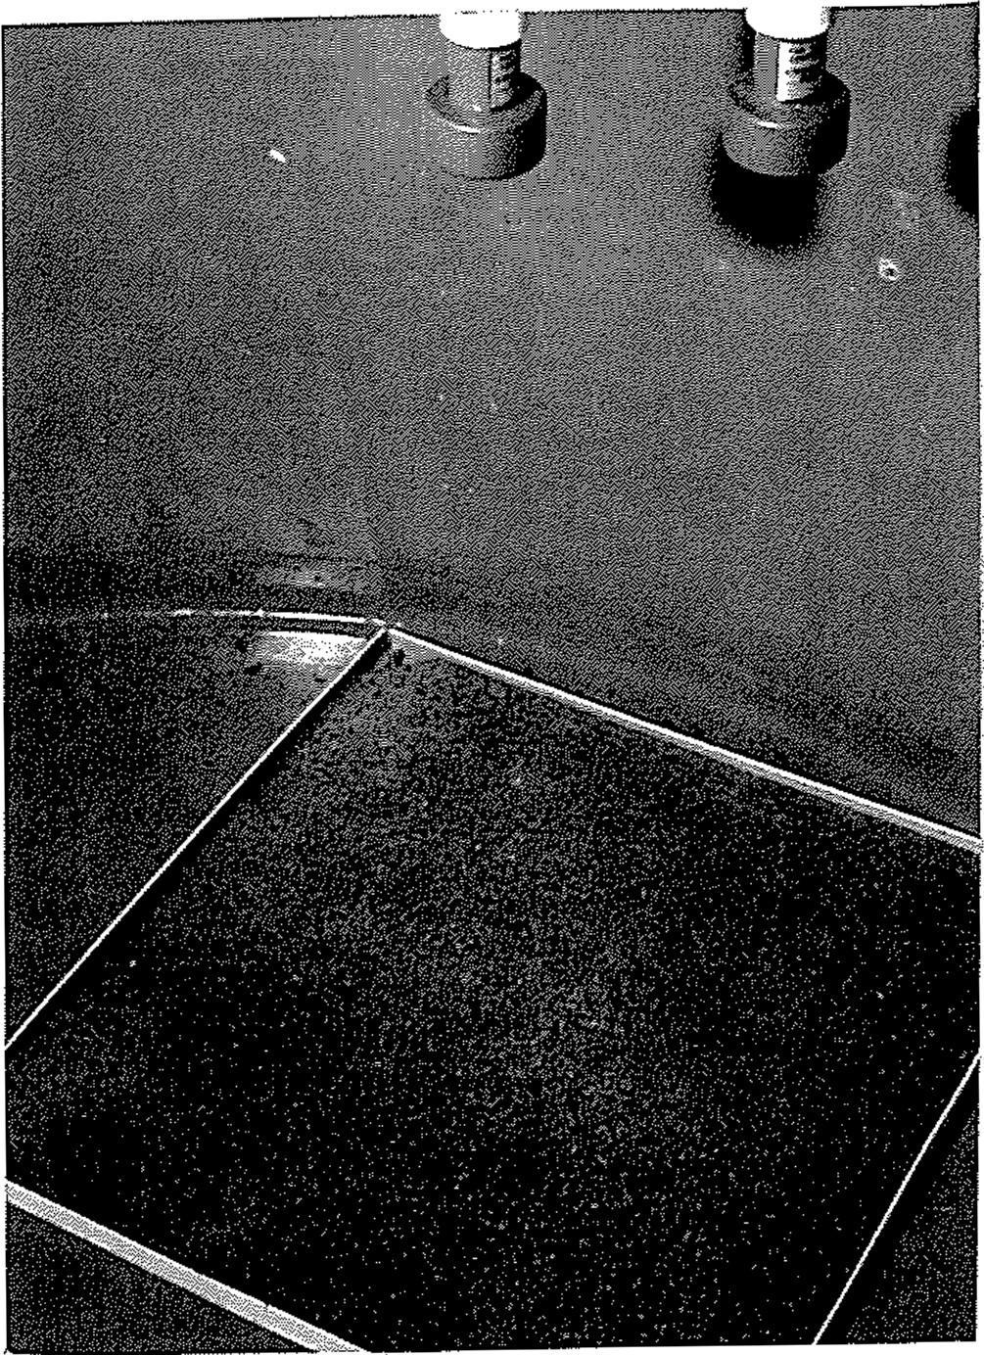 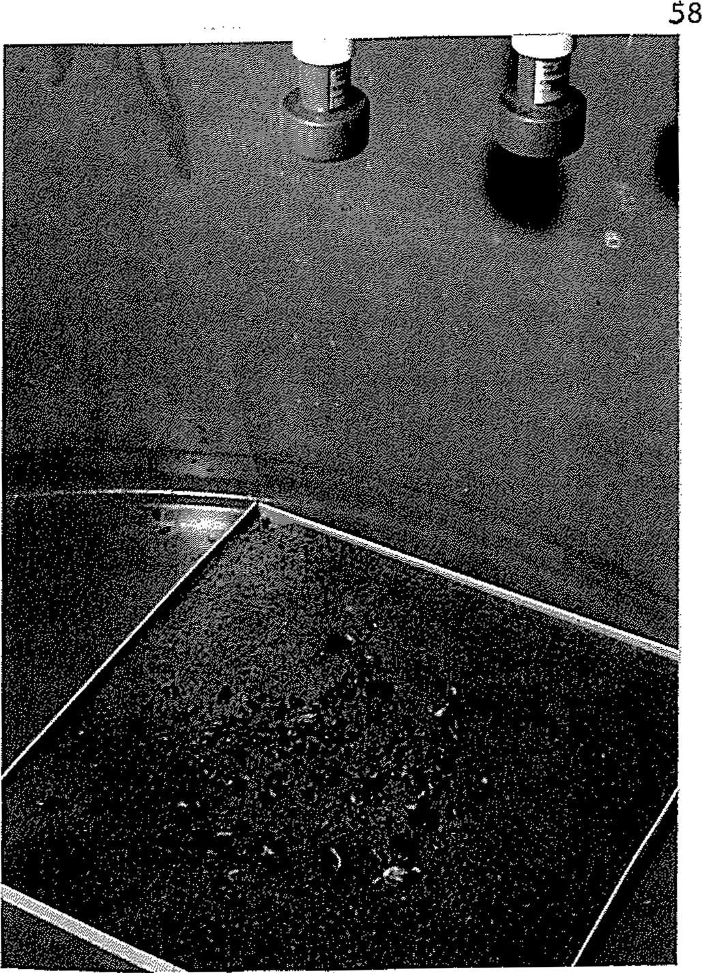

(a) (b)

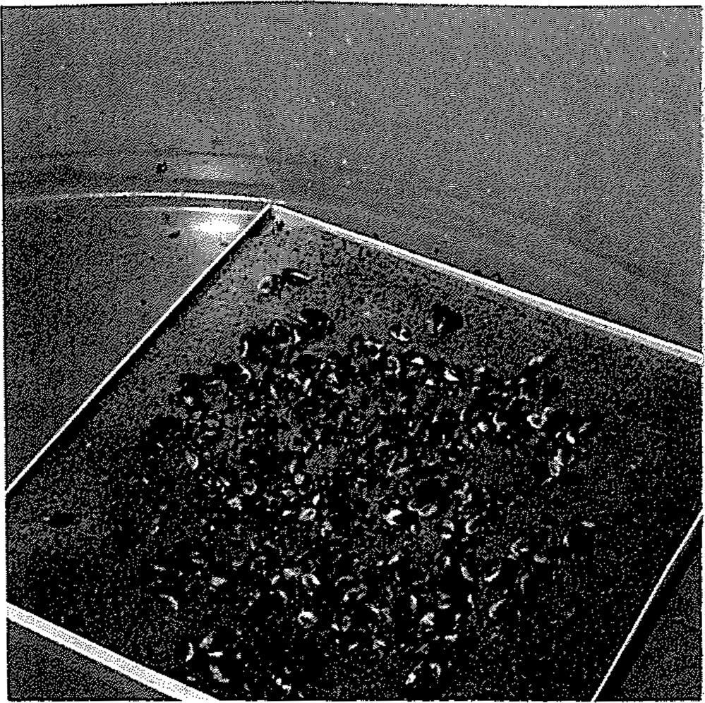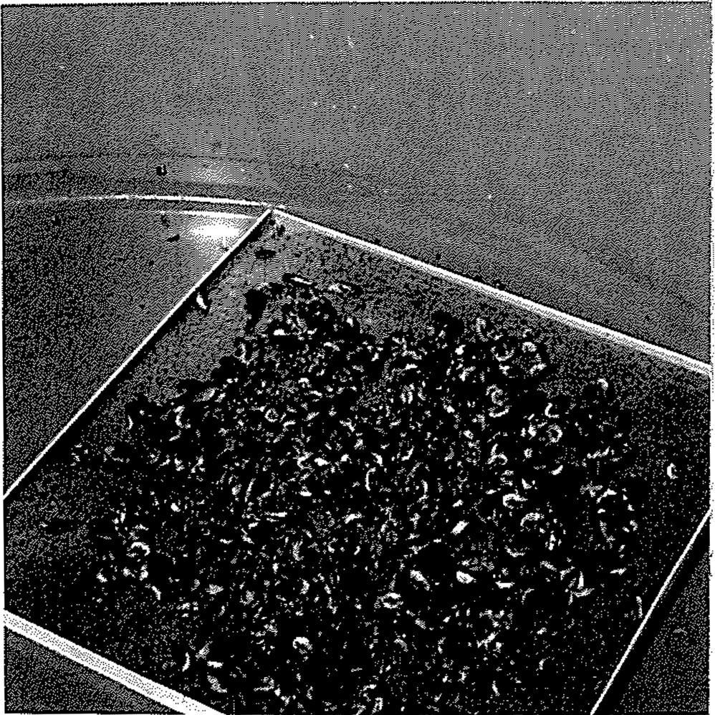

(c) (d)

Fig. 6.3. Ultrasound detection of zebra mussels. Mussel surface density: (a) 0 oz/sq.ft; (b) 4 oz/sq.ft; (c) 10 oz/sq.ft; (d) 16 oz/sq.ft;

59

We examined ultrasonic signals with two central frequencies: 75 kHz and 180 kHz. Very little effect were observed for the 75 kHz signal. The shorter wavelength 180 kHz signal (wavelength equals 8.3 mm which is comparable with mussel size) was much more sensitive for mussel density evaluation. The results of the test are presented in the Figures 6.4 and 6.5. The amplitude of the reflected signals (marked with a circle in Fig. 6.4) decreased with increase of the mussel surface density. The rate the reflected signal reduction was 0.7 dB/oz/sq.ft. This effect is significant enough to be used for the evaluation of the mussel population.

Practical implementation of this method depends on a selection of the central (carrying) :frequency of the probing acoustical signal. The wavelength of the signal should be smaller then the average size of the mussels, i.e. the frequency must be greater then 150 kHz. The reflective parameters of the SUiface (roughness and acoustical impedance) without mussels, distance between the SUiface and the transducers, and absorption of ultrasound in water should be taken into account in .final design.

## 7. CONCLUSION

All major approaches of using acoustic energy for control and monitoring of zebra mussel fouling were studied and analyzed in the course of this project. These include ultrasonic and hydrodynamic cavitation, vibration and sound treatment, and echo-sounding technique. Results and discussions of the related tests are presented at the end of the corresponding chapters in this rep01t.

Analysis of the results of the previous and current investigations indicates that the acoustic control can be used for prevention, but not for cleansing. It is practically feasible to prevent the entering and settling of zebra mussels into facilities, rather than to destroy settled mussel colonies.

We believe that there are three possibly effective and practically efficient ways to utilize acoustic techniques as zebra mussel **preventive** control measures:

60

**TIHE REAL**

**u**

(a)

**7 .249a**

**THIE**

**REAL**

(b)

**2.00011**

I

,........

**,**........

. . •·····



**t..799a j**

***TJHE REAL***

***u***

(c) **-8.199•** L......L.....L.....l....

Fig.6.4. Ultrasound detection of zebra mussels. Reflected 180 kHz signals from mussel with surface density: (a) 0 oz/sq.ft; (b) 8 oz/sq.ft; (c) 16 oz/sq.ft;

61

0

..._,,,

ca -2

* + **,-I**

***VJ***

"'O -4

**(1)**

(.)

**(1)**

-6

*0* -8

**(1)**

"d

;:j

+-> -10

1. .

-12

0 2 4 6 8 10 12

Mussel Density (oz sq.ft)

14 16

Fig. 6.5. Ultrasound detection of zebra mussels. Dependence of amplitude of reflected signals vs. mussel surface density

62

##### Hydrodynamic and ultrasonic (20 - 40 kHz) cavitation to destroy zebra mussel veligers in intake pipes with relatively low water flow rate

* 1. Low frequency (20 - 1000 Hz) and middle frequency (I - 10 kHz) solid-borne vibrations to protect intake pipes and water storage tanks from mussel settling
  2. Low frequency (20 - 1000 Hz) waterborne sound waves to reduce mussel's reproduction and veliger's activity, and to prevent mussels from settling and translocating into screenhouses and other water intake and storage facilities

Ultrasonic (above 150 kHz) echo-location technique can be effectively utilized for monitoring of mussel infestation in various facilities.

Next step in developing the acoustic control methods should be the full scale pilot research. The pilot tests must be carefully designed based on the results and the acoustic performance parameters identified in the present project. Besides a basic system design, which includes hardware, procedure, and projected performance parameters, the pilot tests also should address the issue oflong term effect of sound and vibration on exposed structures.

##### LITERATURE

Ackerman, J.D., and RClaudi. 1991. The early life history of zebra mussels: Overwintering juveniles and post-settlement movements. J. ofShellfish Research. 11:217.

Clarke, KB. 1952. The infestation of waterworks by *Dreissena polymorpha,* a freshwater mussel.

J. Inst. Water Engineers. 6:370-379.

Claudy, R and Ewans D.W., 1993. Chemical addition strategies for zebra mussel *(Dreissena polymorpha)* control on once-through service water systems. *In:* "Zebra Mussels. Biology, Impacts, and Control" Ed. by T.F.Nalepa and D.W.Schloesser, Lewis Publishers, p.563-573.

Conn, D.B, RA.Lutz, Ya-ping Hu, and V.S.Kennedy. 1993. Guide to the identification of larval and postlarval stages of the zebra mussels *Dreissena polymorpha,* and the dark false mussels Mytilopsis leucophaeta. N.Y.Sea Grant.

63

Devore, J. and RPeck. 1986. Statistics. The exploration and analysis of data. West Publishing Company. St.Paul, New York, Los Angeles, San Francisco.

Dyga, AK, 1966. Biofouling of the Dnepropetrovsk water reservoir and the methods of biofouling control. **Ph.D.** thesis, DGU, Dnepropetrovsk. **(In** Russian).

Dolgopol'skaya and Aksel'band, 1964. Effect of ultrasound treatment on sea biofouling. **In**

Proceeding of Sevastopol Biostation, v.18, p.309-324. **(In** Russian).

Dzyuban, N.A. and M.Ya. Kirpichenko. 1971. Biofouling and control of *Dreissena* at the hydro-technical constructions. Pages 76-87 in N.S.Stroganov, ed. Biopovrezhdeniya materialov i izdeliy v presnykh i morskikh vodakh (Bio Damage to materials in fresh and sea waters). Nanka Press, Moscow. **(In** Russian).

Edel, Yu.U. (ed.). 1981. Zashchita gidrosoomzheniy ot korrozii i obrastaniya. (Protection of hydraulic constructions from corrosion and fouling). Energoizdat Press. Moscow. **(In** Russian).

El'piner, I.E. and Z.S.Feigina, 1957. Ultrasound waves in the fight against hydrobionts. Vodosnabzheniye i Sanitamaya Technika, No. 6, p.14-16 **(In** Russian).

Hopkins, J. 1990. The zebra mussel, *Dreissena polymorpha:* A photographic guide to the identification ofmicroscopic veligers. Linmology Section, Water Resources Branch.15pp.

Iwanyzki, S. and RW.McCauley, 1993. Upper lethal temperatures of adult zebra mussel *(Dreissena polymorpha). In:* "Zebra Mussels. Biology, Impacts, and Control" Ed. by T.F.Nalepa and D.W.Schloesser, Lewis Publishers, p.667-675.

Jeuner, HA, 1983. Control of mussel fouling in the Netherlands: Experimental and existing methods. **In:** Condenser Macrofouling Control Technologies - The State-of-the-Art, Symposium, Hyannis, Mass. June 1983.

Jenner, HA and J.P.M.Janssen-Mommen., 1993. Monitoring and control of *Dreissena polymorpha* and other macrofouling bivalves in the Netherlands. *In:* "Zebra Mussels. Biology, Impacts, and Control" Ed. by T.F.Nalepa and D.W.Schloesser, Lewis Publishers, p.537-553.

Johnson, L.E., 1993. Enhanced early detection and enumeration ofzebra mussel (Dreissena spp.) veligers using cross-polarized light. Canadian Jomnal of Fisheries and Aquatic Sciences (submitted).

Karpevitch, AF., 1964. The characte1istic ofreproduction and growth ofbivalves in brackish seas of SSSR Pages 3-60 in Zenkevich L.A. (ed.) Ekologiya bespozvonochnykh ynzhnykh moryey USSR (The ecology ofinvertebrates in southern seas ofUSSR) Moscow. **(In** Russian).

Katchanova, A.A, 1961. Some data *onDreissena polymorpha* Pallas reproduction in the Uchinsk Reservoir (USSR). Tmdy VGBO.11:117-121. **(In** Russian).

64

Kilgour, B., and R Kepple., 1993. Effects of salinity on the survival of zebra mussel veliger laivae. Paper presented at the Third International Zebra Mussel Conference, Toronto, Ontario, 25 February 1993.

Kirpichenko, M.Ya., 1971. Freshwater *Dreissena* on the northern-eastern vicinity of the areal. Proceedings of the Institute of the Biology of Inland Waters of the Academy of Sciences of the USSR, 21(24):130-141. (In Russian).

Klerks, P.L. and P. C.Fraleigh, 1991. Controlling adult zebra mussels with oxidants. J. Am Water works Assoc., 89(12), p.92-100.

Klerks, P.L., Fraleigh, P.C., and RC.Stevenson, 1993. Controlling zebra mussel *(Dreissena polymorpha)* veligers with three oxidizing chemicals: chlorine, permanganate, and peroxide + iron. ***In:*** "Zebra Mussels. Biology, Impacts, and Control" Ed. by T.F.Nalepa and D.W.Schloesser, Lewis Publishers, p.621-641.

Kowalewski, J.J., Colbert, M.B., and P.H.Patrick, 1992. Acoustic control of Zebra Mussels. Ontaiio Hydro research report No 92-136-H.

Kowalewski, J.J., Patric,P.H., and AB.Christie, 1993. Effect of acoustic energy on the Zebra Mussels. ***In:*** "Zebra Mussels. Biology, Impacts, and Control" Ed. by T.F.Nalepa and D.W.Schloesser, Lewis Publishers, p.657-666.

Krainer, KJ.M., Jenner, HA, and D.DeZwru.t, 1989. The valve movement response of mussels: A tool in biological monitoring. Hydrobiologia, 188/189:433-443.

Leitch, E.G. and F.V.Puzzuoli, 1992. Evaluation of coating to control zebra mussel colonization: preliminary results 1990-1991. J. Protective Coatings and Linings, 9(7), p.27-41.

Lubyanov, J.P., Shuvalov, P.P., Dyga,AK, and L.E.Lyashenko, 1968. Study of ultrasonics for control of *Dreissena* fouling in cooling systems. In:Experimental'naya biologiya.Trudy NII Gidrobiologii DGU(Experimental Hydrobiology. Proceedings of NII Gidrobiologii DGU). Dnepropetrovsk.13 :3-7 (In Russian).

Lubyanov, J.P., 1972. Biological Basis for the Protaction of the Hydro-Constractions Against Fouling Fauna in Dnepropetrovskii and Zaporozhskii Water Reservoirs. Dnepropetrovsk University (In Russian).

Ludyanskiy, M.L., 1992. Potential for fouling by zebra mussels at Public Service Electric and Gas Utilities. Report to PSEG. 177pp. Sandwich, MA.

Ludyanskiy, M., D.McDonald, and D.MacNeill., 1993. Impact of the Zebra Mussel: a Bivalve Invader. Bioscience, 43(8) p.533-544.

65

Mackie, G.L., 1991. Biology of exotic zebra mussel, *Dreissena polymorpha,* in relation to native bivalves and its potential impact in Lake St. Clair. Hydrobiologia. 219:251-268.

Mackie, G.L., W.N.Gibbons, B.W.Muncaster, and I.M.Gray., 1989. The zebra mussel, *Dreissena polymorpha:* a synthesis of European experiences and a preview for North America. Report, prepared for: Water Resources Branch, Great Lakes Section. Queen's Printer. Toronto, Ontario. 76pp.

Marsden, J.E., 1991. Zebra mussel monitoring in Lake Michigan, 1991 - Techniques and results. EPRI Zebra Mussel Control Technology Con£, October 22-23, 1991, ltasca,lli.

Marsden, J.E., 1992. Standard protocols for monitoring and sampling zebra mussels. lliinois Natural History Smvey. Biological Notes 138. 38pp.

Mattice, J.S., Fellers, B., Annor, T., Tsou, J., Miller, M., and B.Nott, 1990. Zebra mussel: the EPRI response. Electric Power Research Institute, Palo Alto, CA.

McMahon, R.F., Ussery, T.A., Miller, AC., and B.S.Payne, 1993. Thermal tolerance in zebra mussel *(Dreissena polym01pha)* relative to rate of temperature increase and accumulation temperature. Third International Zebra Mussel Conference, Toronto, Canada.

Mikheev, V.P., 1964. Linear growth of *Dreissena polymorpha* in some reservoirs of the European USSR. Pages 55-65 in B.K Shtegman (ed.) Biology and control of *Dreissena.* Trndy Instituta Biologii Vnutrennikh Vod, Soviet Academy of Sciences Press. (Translated into English).

Neuhauser, E.F., 1993. Thermal treatment to control zebra mussels in circulating water systems. Third International Zebra Mussel Conference, Toronto, Canada.

Nichols, S.J., 1993. Spawning of zebra mussels *(Dreissena polymorpha)* and rearing of veligers under laboratory conditions. Pages 315-329 in T.F. Nalepa, and D.W. Schloesser (eds.) Zebra Mussels: Biology, Impacts, and Control. Lewis Publishers, Chelsea, Ml.

Petrakki, D., 1959. Corrosion of ship hulls /transl. from Italian/. Sudpromgiz Publisher, Leningrad, 14 lpp. (In Russian).

Reutter, J.M., Zebra Mussel Costs. Twin Line, Pages 6-7, June, 1995.

Rozenberg, L.D., 1973. Physical principles ofultrasonic technology, v. l. Plenum Press, N.Y.

Shevtsova, L.V., 1968. Spawning and development of *Dreissena* in the canal Dnieper-Krivoi Rog. Gidrobiol.Zh. 4:70-72. (In Russian).

Sonalysts, Inc. and Aquatic Sciences, Inc., 1991. Zebra Mussel deterrence using acoustic energy. Empire State Electric Energy Research Corporation (ESEERCO), Research report EP 90-38.

66

Sonalysts, Inc. and Aquatic Sciences, Inc., 1992. Evaluation of ultrasound for Zebra Mussel mitigation. ESEERCO, Research report EP 91-17.

Sonalysts, Inc., 1992. Zebra Mussel ultrasound stream treatment test. 1992 Summary results. Sonic Hull Tender, Inc. Ecological Hull System Huntington Beach, CA

Suslick,KS.(Ed.) 1988. Ultrasound. Its Chemical, Physical, and Biological Effects.

Sprung, M., 1990. Costs of reproduction: a study on metabolic requirements of the gonads and fecundity ofthe bivalve *Dreissena polymorpha.* Malacologia. 32:267-274.

Sprung, M., 1993. The other life: an account of present knowledge of the larval phase of *Dreissena Polymorpha.* Pages 39-53 in T.F. Nalepa, and D.W. Schloesser (eds.) Zebra Mussels: Biology, Impacts, and Control. Lewis Publishers, Chelsea, MI.

Walz, N., 1973. Studies on the biology of *Dreissena Polymorpha* in Lake Constance. Arch. Hydrobiol. Suppl. 42:452-482.

Walz, N., 1975. Die besiedlung von kuntlichen substraten durch larven von *Dreissena Polymorpha.* Arch. Hydrobiol. Suppl. 47:423-431.

Walz, N., 1978. The energy balance ofthe freshwater mussel *Dreissena Polymorpha* in laboratory experiments and in Lake Constance. 2. Reproduction. Arch. Hydrobiol. Suppl. 55:106-119.

Walz, N., 1991. New invasions, increase, and ecological equilibrium of *Dreissena Polymorpha* populations in central and southern European lakes and rivers. Paper presented at the Second International Zebra Mussel Con£ Rochester, N.-Y., 19 November 1991.

Zebra mussel monitoring and control guide. 1993. Electric Power Research Institute TR- IO1782s, Palo Alto, CA.

67

### Acknowledgements

We are very grateful to biologists Dr. Michael Ludyanskiy of LONZA, Inc. and Dr. David A Wright of Chasapic Biological Laboratory, University of Maryland, both seived as consultants for the project, for their valuable contribution.

Cornell University Biological Field Station provided its facilities on the Oneida Lake in Bridgeport, NY. particular we are very thankful to Dr. Edward L. Mills of Cornell University for the technical support.

We also express our appreciation to Marine Biocontrol Corporation (Sandwich, MA) and Triton Thalassic Technologies, Inc. (Ridgefield, CT) for their participation in some experiments.

[View publication stats](https://www.researchgate.net/publication/256981297)